  - Secured by Design

IACS E27/Rev.1 2023 Guideline
Version 1.0

CAUTION
THIS DOCUMENT CONTAINS CONFIDENTIAL PROPRIETARY INFORMATION. HENCE, THE REPRODUCTION, TRANSFER AND/OR UTILIZATION IN WHOLE OR PART FOR ANY PURPOSE ARE PROHIBITED WITHOUT THE WRITTEN PERMISSION OF EY MCH
REF. NO | EY-HANWHA-P-PKG(R1)
ISSUED DATE | 2025-03-04
SUBMITTED TO | MOL(LPGC)-HO-SYSTEMSUPPLIER  (TARGETSYSTEM)
COVERAGE | ClassNK
  - EY Maritime Cyber Hub
© 2025 EY Consulting. All rights reserved.
Table of contents
Introduction 6
A. Importance of Maritime Cybersecurity 6
B. Understanding UR E27 in the Maritime Cybersecurity Framework 6
C. Overview of International Standards & Regulations 7
LEVELⅠ. Scope of applicability 8
A. General 8
B. Vessels within the scope 9
C. Computer-based system within the scope 11
1. Computer-based system 11
2. Categorization of system based on Failure effects 11
3. Examples of CBS within the scope 12
D. Device in the same Security Zone as the applicable computer-based system 14
E. Exclusion based on Risk assessment 15
LEVEL Ⅱ. Approval Process 17
A. General 17
B. Individual product approval process 20
1. System is not type approved 20
2. System is type approved 21
3. Previously approved system installed on sister vessel 22
C. Type Approval process 23
LEVEL Ⅲ. System Requirements 25
A. General 25
B. Required security capabilities 25
1. Human user identification and authentication (Ref. IEC62443-3-3 / SR 1.1) 25
2. Account management (Ref. IEC62443-3-3 / SR 1.3) 26
3. Identifier management 26
4. Authenticator management (Ref. IEC62443-3-3 / SR 1.5) 27
5. Wireless access management (Ref. IEC62443-3-3 / SR 1.6) 28
6. Strength of password-based authentication (Ref. IEC62443-3-3 / SR 1.7) 29
7. Authenticator feedback (Ref. IEC62443-3-3 / SR 1.10) 29
8. Authenticator management (Ref. IEC62443-3-3 / SR 2.1) 30
9. Wireless use control (Ref. IEC62443-3-3 / SR 2.2) 30
10. Use control for portable and mobile devices (Ref. IEC62443-3-3 / SR 2.3) 31
11. Mobile code (Ref. IEC62443-3-3 / SR 2.4) 31
12. Session lock (Ref. IEC62443-3-3 / SR 2.5) 32
13. Auditable events (Ref. IEC62443-3-3 / SR 2.8) 33
14. Audit storage capacity (Ref. IEC62443-3-3 / SR 2.9) 34
15. Response to audit processing failures (Ref. IEC62443-3-3 / SR 2.10) 34
16. Timestamps (Ref. IEC62443-3-3 / SR 2.11) 35
17. Communication integrity (Ref. IEC62443-3-3 / SR 3.1) 36
18. Malicious code protection (Ref. IEC62443-3-3 / SR 3.2) 36
19. Security functionality verification (Ref. IEC62443-3-3 / SR 3.3) 37
20. Deterministic output (Ref. IEC62443-3-3 / SR 1.5) 38
21. Information confidentiality (Ref. IEC62443-3-3 / SR 4.1) 39
22. Use of cryptography (Ref. IEC62443-3-3 / SR 4.3) 39
23. Audit log accessibility (Ref. IEC62443-3-3 / SR 6.1) 40
24. Denial of service protection (Ref. IEC62443-3-3 / SR 7.1) 41
25. Resource management (Ref. IEC62443-3-3 / SR 7.2) 41
26. System backup (Ref. IEC62443-3-3 / SR 7.3) 42
27. System recovery and reconstitution (Ref. IEC62443-3-3 / SR 7.4) 43
28. Alternative power source (Ref. IEC62443-3-3 / SR 7.5) 43
29. Network and security configuration settings (Ref. IEC62443-3-3 / SR 7.6) 43
30. Authenticator management (Ref. IEC62443-3-3 / SR 7.7) 44
C. Additional security capabilities 45
31. Multifactor authentication for human users (Ref. IEC62443-3-3 / SR 1.1 RE 2) 45
32. Software process and device identification and authentication (Ref. IEC62443-3-3 / SR 1.2) 46
33. Authenticator management (Ref. IEC62443-3-3 / SR 1.11) 46
34. Authenticator management (Ref. IEC62443-3-3 / SR 1.12) 47
35. Access via Untrusted Networks (Ref. IEC62443-3-3 / SR 1.13) 47
36. Explicit access request approval (Ref. IEC62443-3-3 / SR 1.13 RE 1) 48
37. Authenticator management (Ref. IEC62443-3-3 / SR 2.6) 48
38. Cryptographic integrity protection (Ref. IEC62443-3-3 / SR 3.1 RE 1) 49
39. Input validation (Ref. IEC62443-3-3 / SR 3.5) 49
40. Session integrity (Ref. IEC62443-3-3 / SR 3.8) 50
41. Invalidation of session IDs after session termination (Ref. IEC62443-3-3 / SR 3.8 RE 1) 50
D. Compensating countermeasure 51
E. Unapplicable Requirements 51
LEVEL Ⅳ. Documents 52
A. General 52
B. Mandatory Documents irrespective of Type Approval 52
1. Computer Based System asset inventory 52
2. Topology diagrams 53
C. Mandatory Document for Type Approval 54
1. Test reports 54
D. Required documents without Type Approval 55
1. Description of Security capabilities 55
2. Test procedure of security capabilities 61
3. Security configuration guidelines 67
4. Secure development lifecycle documents 68
5. Plans for maintenance and verification of the CBS 74
6. Information supporting the owner’s incident response and recovery plan 75
7. Management of change plan 77
Appendix. 80

Introduction

Importance of Maritime Cybersecurity
The maritime industry is undergoing rapid digital transformation, integrating advanced technologies such as IoT, automation, and AI-driven navigation systems. While these innovations enhance efficiency and operational capabilities, they also introduce new cybersecurity risks that can threaten ship safety, disrupt global supply chains, and cause severe financial and reputational damage.

Cyber threats targeting vessels, onboard systems, and port infrastructure are increasing, with incidents ranging from ransomware attacks to GPS spoofing and unauthorized system access. As maritime operations become more connected, ensuring robust cyber resilience is no longer optional but an operational necessity. To address these challenges, shipowners must adopt a proactive cybersecurity strategy that includes risk assessment, regulatory compliance, and the integration of resilient security measures into ship design, construction, and operation.

Understanding UR E27 in the Maritime Cybersecurity Framework
In response to these emerging risks, the International Association of Classification Societies (IACS) issued two new Unified Requirements (URs) in April 2022: UR E26 and UR E27.
- UR E26 applies to ships and focuses on cyber resilience through security zoning and risk assessment for computer-based systems (CBS).
- UR E27 applies to onboard systems and equipment, establishing requirements to ensure they remain resilient against cyber-attacks throughout their lifecycle.
Although both URs provide a baseline framework for maritime cyber resilience, this guideline specifically focuses on UR E27. The objective is to clarify its scope, requirements, and implementation aspects for onboard systems and equipment, enabling shipowners and equipment manufacturers to strengthen resilience where it is most directly applied.

Overview of International Standards & Regulations
While UR E27 focuses on the cyber resilience of onboard systems and equipment, it should be understood within the broader context of international cybersecurity regulations and standards. Readers seeking more comprehensive perspectives on maritime cybersecurity are encouraged to consult the following frameworks:

IACS Unified Requirements (UR)
E10 – Covering environmental performance for the system hardware.
E22 – Covering safety of equipment for the functionality of the software.
E26 – Covering cyber resilience through security zoning and risk assessment for computer-based systems.
IMO MSC.428(98) Cyber Risk Management
Mandates shipowners and operators to integrate cybersecurity risk management into their ISM Code Safety Management System (SMS).
NIST Cybersecurity Framework (CSF) 2.0
A globally recognized framework that helps organizations implement best practices for Identify, Protect, Detect, Respond, and Recover functions.
Maritime and Port Authority (MPA) Cybersecurity Guidelines
Provides specific cybersecurity compliance requirements for ports and vessels operating in Singapore, the US, and the EU.
Ensuring compliance with these regulations is critical for shipowners to meet global cybersecurity requirements, prevent cyber incidents, and maintain operational safety.

LEVELⅠ. Scope of applicability

General
This chapter describes the scope and applicability of UR E27
UR E27 applies mandatorily to vessels contracted for construction on or after 1 July 2024, within defined ship types and tonnage limits, and to CBS categorized as Category II or III in accordance with UR E22. Systems falling into these categories are considered to have failure effects that could lead to hazardous or catastrophic conditions and are therefore within the mandatory application of this requirement.

Additionally, the scope of applicability extends to systems located in the same security zone as applicable CBS, as defined in UR E26, ensuring that no connected or adjacent systems become a weak point in cyber security. Conversely, certain ship types and CBS functions (e.g., small vessels, fishing vessels, non-mechanically propelled ships, and Category I systems) are subject only to non-mandatory guidance or may be excluded through a risk assessment process, provided sufficient evidence is approved by the Society.

Through these provisions, UR E27 establishes a unified and risk-based framework for determining which vessels and computer-based systems fall under its mandatory requirements, while also defining conditions under which systems may be exempted or treated as guidance.

Following flowchart (Figure 1) can be used to help determine this applicability. It shows how vessel type, CBS categorization, and security zone considerations interact to determine whether UR E27 requirements are mandatory, provided as guidance, or may be excluded upon approval by the Society.
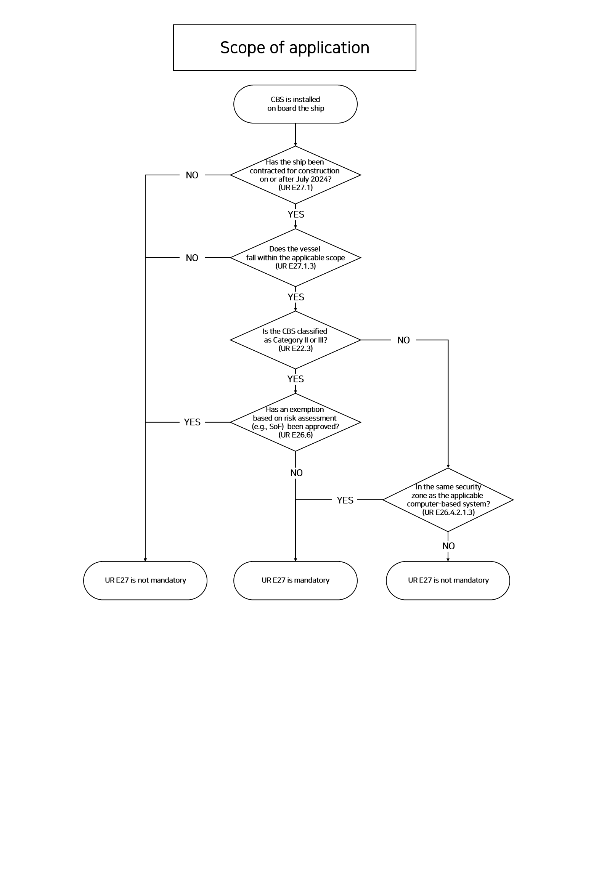
Figure 1 Scope of Applicability flowchart

Vessels within the scope
(E27 1 General의 note 부분)
2024년 7월 1이후 계약된 선박~

This guideline specifies unified requirements for cyber resilience of on-board systems and equipment which are installed on vessels whose contracts for construction are made on or after 1 July 2024.
“Contracts for construction” date means the date on which the contract to build the vessel is signed between prospective owner and the shipbuilder.

(ClassNK 기준)
* For ClassNK, UR E27 shall apply to computer-based systems installed on board vessels registered with ClassNK, whose contracts for construction are signed on or after 1 July 2024.

(E27 1.3 Scope of applicability)
The requirements for this guideline are applicable to computer-based systems for the following types of vessels
Mandatory requirements for
- Passenger ships (including passenger high-speed craft) engaged in international voyages
- Cargo ships of 500 GT and upwards engaged in international voyages
- High speed craft of 500 GT and upwards engaged in international voyages
- Mobile offshore drilling units of 500 GT and upwards
- Self-propelled offshore structures engaged in construction (i.e., wind turbine installation
- maintenance and repair, crane units, drilling tenders, accommodation, etc.)

Non-mandatory guidance to
- Ships of war and troopships
- Cargo ships less than 500 gross tonnage
- Vessels not propelled by mechanical means
- Wooden ships of primitive build
- Passenger yachts (passengers not more than 12).
- Pleasure yachts not engaged in trade
- Fishing vessels
- Site specific offshore installations (i.e. FPSOs, FSUs, etc)

Computer-based system within the scope
(ClassNK Chapter1 Branch2 기준)

Computer-based system
A computer-based system is a programmable electronic device or interoperable set of programmable electronic devices that are organized to achieve one or more specified purposes such as collection, processing, maintenance, use, sharing, dissemination, or disposition of information. A programmable electronic device is a physical component in which software is installed and includes a programmable logic controller (PLC).

Categorization of system based on Failure effects
Computer-based Systems that can potentially lead to dangerous situations for human safety and safety of the ship and/or threat to the environment are subject to this document. Table 1 provides the categorization of systems based on the potential severity of the consequences if the system serving the function fails.
(E22 3 System categories = part X 3.3)
Category | Failure effects | Typical System functionality
I | Those systems whose failure will not lead to dangerous situations for human safety, vessel safety or a threat to the environment. | Monitoring, informational and administrative functions
II | Those systems whose failure could eventually lead to dangerous situations for human safety, vessel safety or a threat to the environment | Vessel alarm, monitoring and control functions that are necessary to maintain the vessel in its normal operational and habitable conditions
III | Those systems whose failure could immediately lead to dangerous or catastrophic situations for human safety, vessel safety or a threat to the environment. | - Control functions for maintaining vessel  propulsion and steering  - Vessel safety functions
Table 1 CBS System categories
Category I systems are normally not subject to verification by the Society since a failure of such systems does not lead to dangerous situations. However, information pertinent to Category I systems is to be provided upon request to determine the correct category and ensure that they do not influence the operation of Category II and III systems.

Examples of CBS within the scope
(ClassNK Chapter1 Branch2 기준)
The following are examples of computer-based systems that may fall within the scope of application of UR E27. The failure effects of each system shall always be evaluated in the context of the specific vessel in question; therefore, the applicability of this UR may vary from one vessel to another. The examples provided are not exhaustive and are given for reference only. Systems not listed may nevertheless be deemed applicable or non-applicable, depending on their functions and failure effects..

Ship Functions | Computer-Based System
Propulsion | Engine control systems
 | Engine remote control systems
 | Main boiler control systems
 | CPP control systems
 | Electric propulsion control systems
 | FGSS control systems
Machinery alarm and monitoring systems
(including data loggers)
 | Waterjet propulsion systems
 | Engine telegraph
Steering | Steering system control systems
 | Azimuth thruster control systems
Anchoring and mooring | Windlass control systems
 | Mooring winch control systems
Electrical power generation  and distribution | Generator engine control systems  (including power management systems)
 | Electric power converters (for electric propulsion ship)
Battery management systems
(consisting of lithium-ion batteries with total capacities of
20 kWh or more, and associated equipment)
Fire detection and  extinguishing systems | Fire detection and alarm systems
 | Fixed foam fire extinguishing systems
 | Fixed CO2 fire extinguishing systems
 | Fixed deck foam systems
 | Fixed local application fire-fighting systems
 | Water-spraying systems
 | Dry chemical fire-extinguishing equipment
Bilge and ballast system,  loading computer | Ballast transfer valve remote control systems
 | Loading computers
Watertight integrity and  flooding detection | Watertight door power opening/closing devices
 | Water level detection and alarm systems
Lighting  (e.g. emergency lighting, low locations, navigation lights, etc.) | Emergency lighting
 | Low location lighting
 | Navigation lighting control systems
Safety system  (Disruption or functional impairing may pose risks to ship operations  (e.g. emergency shutdown system, cargo safety system,  pressure vessel safety system,  gas detection system, etc.) | Inert gas systems
 | Cargo monitoring control systems
 | Liquefied gas emergency shutdown systems
 | Flammable gas detection systems
 | Reliquefication plants
 | Auxiliary boiler control systems
 | GCU control systems
 | Gas fuel tank monitoring and control systems
Navigational systems required  by statutory regulations | Radar
 | Transmitting heading devices (THD)
 | Electronic plotting aids (EPA)
 | Automatic identification systems (AIS)
 | Automatic tracking aids (ATA)
 | Voyage date recorders (VDR)
 | Automatic radar plotting aids (ARPA)
 | Heading control systems (HCS)
 | Echo sounding devices
 | Track control systems (TCS)
 | Global navigation satellite systems (GPS)
 | Long range identification and tracking systems (LRIT)
 | Sound reception systems
 | Bridge navigational watch alarm systems (BNWAS)
 | Speed and distance measuring devices
 | Electronic chart display and information systems (ECDIS)
 | Electronic Inclinometer
 | Rate-of-turn indicator
Internal and external communication systems required by class rules and  statutory regulations | General emergency alarm
 | Public addressor
 | NAVTEX receiver
 | VHF DSC device
 | EGC receiver
 | DSC device
 | VHF DSC continuous watch device
 | DSC continuous watch device
 | GMDSS radio installation
Others | Dynamic positioning systems (DPS)
Table 2

Device in the same Security Zone as the applicable computer-based system
(ClassNK Chapter1 Branch 3 Devices in the same security zone as the applicable
computer-based system)
어떤 부품이 어떤 security zone에 속할지 모름으로, Type approval을 받는 편이 낫다는 내용 추가
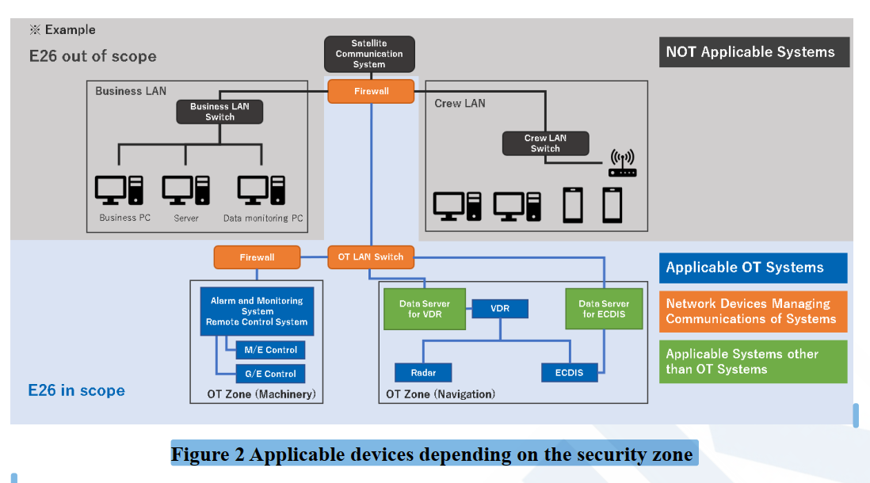

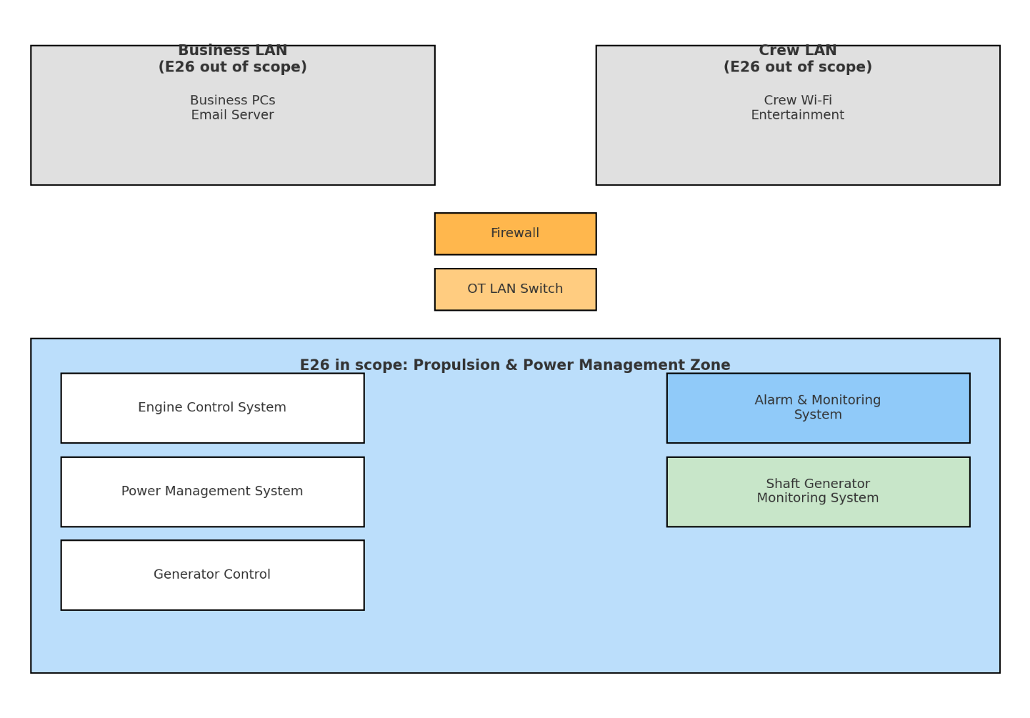
Figure 2 shows a concept of a "security zone" formed by the applicable computer-based system described in Branch B. A security zone is a group of onboard networks, consisting of one or more network segments that satisfy the same security policy. Zone boundary devices must be placed between different security zones. In this case, zone boundary device and network devices such as LAN switches shown in orange as in Figure 2, located on computer-based system side of those devices, and other systems shown in green as "Applicable systems other than the applicable computer-based system" that communicate directly with the applicable computer-based system without zone boundary device in between, and which are not designated as Branch B "computer systems included in the scope of application", are also applicable.

Exclusion based on Risk assessment
(얘가 -> SoF Chapter1 Branch 4 Exclusion based on Risk assessment)

For computer-based systems described in Branch B, if they are subject to risk assessments and approved by the Society to be excluded
ClassNK에서는 Statement of Fact라고 불린다

(PartX 5.5 Risk Assessment for Exclusion of Computer-based System from the Application of Requirements (5.5.4 Acceptance Criteria)
Exclusion of a computer-based system falling under the scope of applicability of this Chapter from the application of relevant requirements can be accepted by the Society only if assurance is given that the operation of the computer-based system has no impact on the safety of operations regarding cyber risk. The said exclusion may be accepted for a computer-based system which does not fully meet the additional criteria listed below but is provided with a rational explanation together with evidence and is found satisfactory by the Society. Society may also require the submission of additional documents to consider the said exclusion.
The following criteria are to be met to exclude a system from the scope of applicability of this Chapter:
(1) The computer-based system is to be isolated (i.e, have no IP-network connections to other systems or networks).
(2) The computer-based system has no accessible physical interface ports. Unused interfaces are to be logically disabled. It is not to be possible to connect unauthorized devices to the computer-based system.
(3) The computer-based system is to be in areas to which physical access is controlled.
(4) The computer-based system is not to be an integrated control system serving multiple ship functions as specified in the scope of applicability of this Chapter.
The following additional criteria are to be considered for the evaluation of risk level acceptability:
(1) The computer-based system should not serve ship functions of category III.
(2) Known vulnerabilities, threats, potential impacts deriving from a cyber incident affecting the computer-based system have been duly considered in the risk assessment.
(3) The attack surface for the computer-based system is minimized, having considered its complexity, connectivity, physical and logical access points, including wireless access points

LEVEL Ⅱ. Approval Process

General

The approval process of UR E27 defines how computer-based systems (CBS) shall be verified for cyber resilience before installation on board. The pathway depends on whether the system already holds a valid Type Approval certificate or has been previously approved for a sister vessel.
- With Type Approval certificate:
A reduced set of documents may be submitted, supported by supplier test reports, in lieu of surveys and FAT.
- Without Type Approval certificate:
A complete set of documents is required, followed by plan approval and verification activities such as survey and FAT.
- Previously approved for sister vessel:
Previously approved documentation may be reused, with plan approval and survey/FAT as applicable.
Following flowchart (Figure 2) can be used to help determine approval process.

(ClassNK Chapter2 Approval Process)
기본적으로 Individual product approval(제품이 들어가는 배 마다 받는 인증 -> E27)
Type approval(부품 단위의 “사전 인증”-> 미리 E27 요구사항 충족 여부 확인)
2개의 approval이 존재하고
Individual의 경우
1) type approval을 받은 경우,
(Document 간소화 + E27 Survey 생략 -> 제품 제작 과정에 대한 survey 생략
but, 선박 탑재 시의 survey는 받아야함 )
2) type approval을 안 받은 경우,
(모든 Document 제출 + E27 Survey 필요)
3) Sister vessel에 허가되어 장착된 경우
(모든 Document 제출 + E27 Survey 필요 but, 일부 문서 재사용 가능)

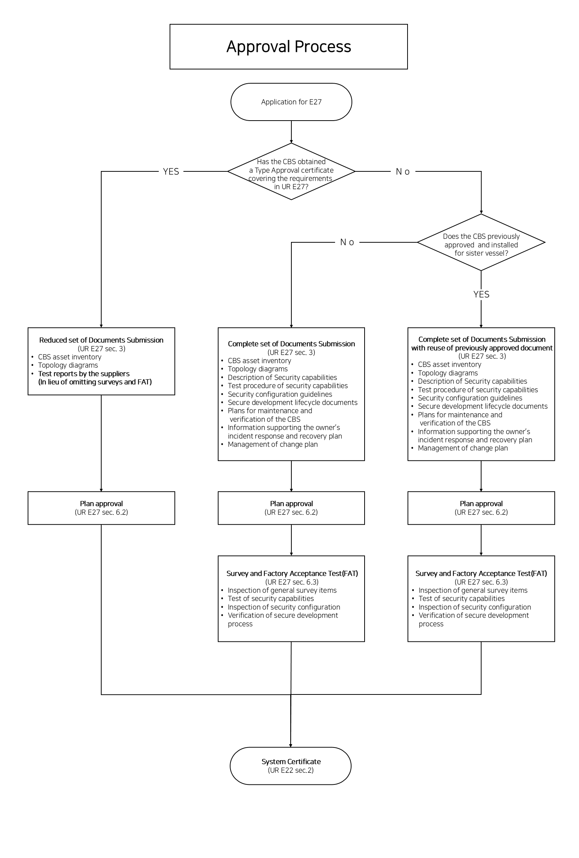
Figure 2 Approval process flowchart

For computer-based system to which this chapter applies, there are two types of approval: individual product approval and type approval. A summary of each type of approval is as follows.

Approval type
Individual product approval: This refers to product approval. Chapter 4, Part X (UR E27) ap-plies to computer systems installed on applicable ships, and approval is required for each product.
Type approval: This refers to type approval. Part of the process required for individual product approval is eliminated by conducting the examinations and inspections of representative types specified in Chapter 4, Part X (UR E27) before it is prepared to be installed on board a ship

Individual product approval process
The process for approving an individual product is divided into several processes depending on whether the system has type approval and on the approval records for sister vessels. The overview of processes is as follows

The system is not type approved:
In principle, all documentation and surveys are required.
System is type approved:
Some documentation may be omitted. In addition, surveys may also be omitted in lieu of the submission of “test reports”.
Previously approved system installed on sister vessel:
After comparing and examining any differences with the previously approved system, some or all documentation may be reused. The surveys are required.
The process for approving an individual product is divided into several processes depending on whether the system has type approval and on the approval records for sister vessels. The overview of processes is as follows

System is not type approved:
In principle, all documentation and surveys are required.
System is type approved:
Some documentation may be omitted. In addition, surveys may also be omitted in lieu of the submission of “test reports”.
Previously approved system installed on sister vessel:
After comparing and examining any differences with the previously approved system, some or all documentation may be reused. The surveys are required.

System is not type approved
In principle, all documentation must be submitted on a ship-by-ship basis for systems that are not approved for use. Please use NK-PASS to submit relevant documentation. Please refer to the following URL for more information on NK-PASS.
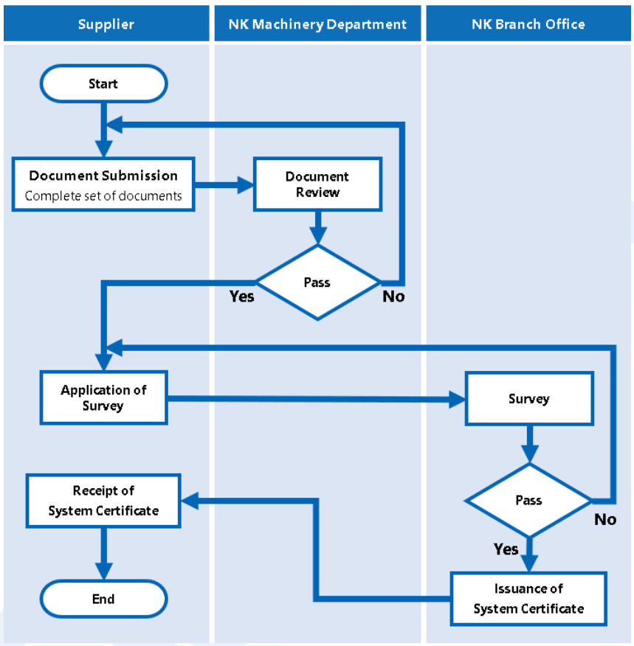

System is type approved
The submission of some of the required documents may be exempted for systems that are type approved. Applications for exemptions from submission of documents are to include the following information.
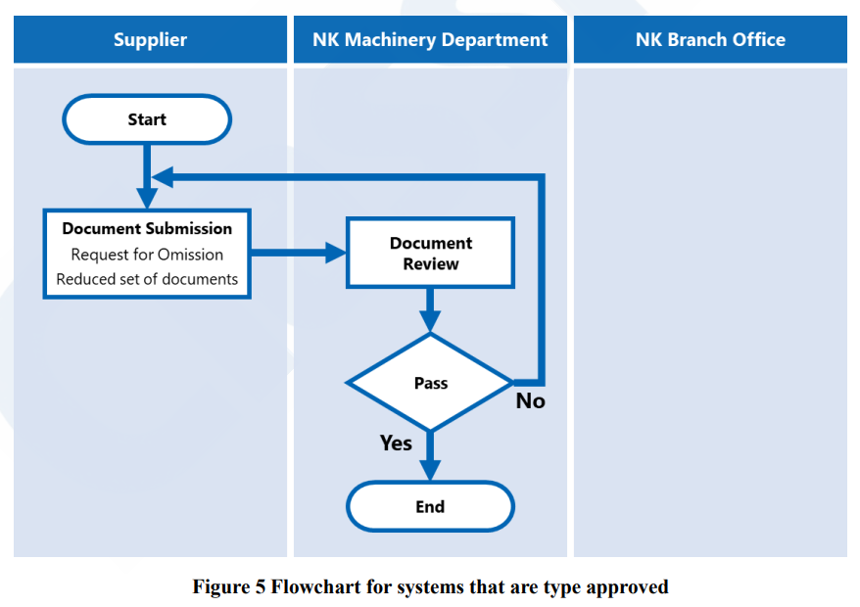

Previously approved system installed on sister vessel
Document submission and review
The reuse of previously approved documents for second and subsequent ships for previously
approved systems installed on sister vessels is possible when there are no modifications made to
such systems and there are no changes in the previously approved documents. If you wish to reuse
the documents, please apply through NK-PASS, our drawing submission system.
Surveys
Surveys may still be requested where desired by contacting the nearest branch office as described
in “System is not type approved”. Please refer to following URL for a current list of NK branch
offices.
URL: https://www.classnk.com/hp/en/directory/dir_top.aspx
The following documents are required for surveys

Type Approval process
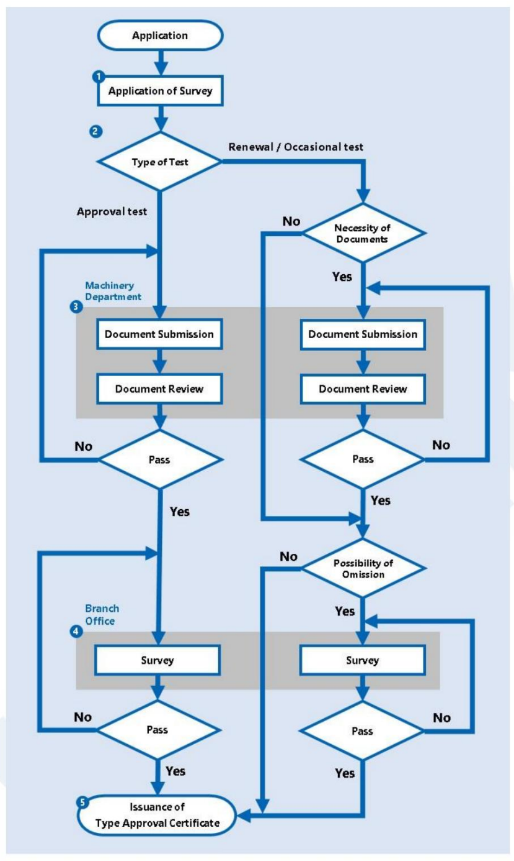

Applicants for type approval should submit application form “Form 7-10(E)” to the Machinery Department (email: mcd@classnk.or.jp) by NK-PASS or email after filling in the required items. The application form can be downloaded from the “Class Survey (Manufacturers)” section of the Society’s official website. Please use the following URL to download the form.

LEVEL Ⅲ. System Requirements

General
The requirements in this section are based on selected requirements from IEC 62443-3-3. Six Foundational Requirements shall be established as technical security requirements, under which a total of 30 requirements are allocated. In addition, 11 Additional Security Capabilities are specified to address cases where systems interface with an untrusted network.

In order to cover 다양한 societies, we made 조금 엄격한 requirements 내용 추가 할지 고민..

Required security capabilities

Protect against casual or coincidental access by unauthenticated entities

Human user identification and authentication (Ref. IEC62443-3-3 / SR 1.1)
Purpose
To reduce the risk of being used by people who are not authorized to use the system. If the system does not identify and authenticate, an attacker can access without authorization. This could affect the operation of the vessel. This requirement does not require individual identification and authentication (that is, individual identification) and it allows role-based identification and authentication.
Requirements
- The CBS SHALL identify and authenticate all human users who access the system, whether directly or through interfaces. Each organizational user SHALL be uniquely identified and authenticated prior to being granted access.
- The CBS SHALL collect personally identifiable information (PII) from applicants as part of the resolution process. This information includes name, address, date of birth, email address, and phone number, which are used to establish and verify identity.
- Permitted types of authenticators include the following:
1. Memorized Secret
2. Look-Up Secret
3. Out-of-Band Device
4. Single-Factor One-Time Password (OTP) Device
5. Multi-Factor OTP Device
6. Single-Factor Cryptographic Software
7. Single-Factor Cryptographic Device
8. Multi-Factor Cryptographic Software
9. Multi-Factor Cryptographic Device

Account management (Ref. IEC62443-3-3 / SR 1.3)
Purpose
To properly manage users of the system. Improper management can result in unauthorized access by someone who does not have permission to use it.
Requirements
- The CBS SHALL provide the capability for authorized users to manage all system accounts. This includes adding, activating, modifying, disabling, and removing accounts in accordance with defined policies and procedures.
- Account managers SHALL be assigned to oversee account operations. Requests to create accounts SHALL require approval by designated personnel or roles.
- The CBS SHALL ensure that accounts are created, enabled, modified, disabled, and removed following established policy and procedures.

Identifier management
Purpose
To manage identifiers by user, group, and role in accordance with the requirement.
Requirements
- The CBS SHALL provide the capability to manage identifiers for users, groups, and roles. This includes assigning and maintaining unique identifiers to ensure accurate tracking of user activities and enforcement of access controls.
- The CBS SHALL enforce prerequisites and criteria for group and role membership to ensure that only authorized users are assigned to specific groups and roles. For each account, the CBS SHALL define and maintain information regarding authorized users, group and role membership, and access authorizations, including assigned privileges.
- The CBS SHALL manage system identifiers by requiring authorization prior to assigning an individual, group, role, service, or device identifier. Typically, individual identifiers are the usernames assigned to system accounts for those individuals.

Authenticator management (Ref. IEC62443-3-3 / SR 1.5)
Purpose
To ensure the confidentiality of the authenticator. Leaking the authenticator could allow it to be misused by an attacker. This could affect the operation of the vessel
Requirements
- The CBS SHALL provide the capability to initialize authenticator content, change all default authenticators upon system installation, change or refresh authenticators as required, and protect authenticators from unauthorized disclosure and modification during storage and transmission.
- The CBS SHALL establish initial authenticator content for any authenticators it issues and SHALL ensure that authenticators provide sufficient strength of mechanism for their intended use. The CBS SHALL establish and implement administrative procedures for initial authenticator distribution, handling lost, compromised, or damaged authenticators, and revoking authenticators when necessary.
- Default authenticators SHALL be changed prior to first use. All authenticators SHALL be changed or refreshed at defined intervals or upon specified events. Authenticator changes SHALL occur for group or role accounts whenever membership to those accounts changes.
- Authenticator content SHALL be protected from unauthorized disclosure and modification. Unencrypted static authenticators SHALL NOT be embedded in applications or other forms of static storage. Cached authenticators SHALL not be used beyond a defined time period.
- Memorized secrets that are randomly generated by the CBS or verifier, such as during enrollment or when a user requests a new PIN, SHALL be at least 6 characters in length and SHALL be generated using an approved random bit generator that complies with NIST SP 800-90A Revision 1.
- Approved DRBG mechanisms include:
1. Hash_DRBG
2. HMAC_DRBG
3. CTR_DRBG, which uses AES in counter mode
These mechanisms SHALL support security strengths of 112, 128, 192, or 256 bits. Approved cryptographic algorithms include SHA-256, SHA-512, AES-128, AES-192, and AES-256.

Wireless access management (Ref. IEC62443-3-3 / SR 1.6)
Purpose
to enhance security under wireless communications where there is a risk of cyber-attacks. The major difference between wireless and wired communications is that an attacker can easily access a network remotely within range of radio waves. In the case of wired communications, installing a blocker on a physical port and managing entry and exit are also effective. However, these measures are not effective for wireless communications. Therefore, it is necessary to provide identification and authentication functions that can be used under wireless connections so that only authorized users can access them. Requirements
- The CBS SHALL provide the capability to identify and authenticate all users — including human users, software processes, and devices — engaged in wireless communication before granting access to system resources.
- To achieve this, the CBS SHALL employ secure wireless access control mechanisms. For example, the CBS MAY use solutions based on the IEEE 802.11i standard, which incorporates the IEEE 802.1X framework for port-based access control. This framework supports centralized, mutual authentication through Extensible Authentication Protocol (EAP) methods and an Authentication Server (AS), typically using RADIUS or Diameter protocols for authentication traffic.
- The CBS SHALL ensure that wireless access is blocked until successful authentication is completed, preventing unauthorized parties from gaining access to wireless network resources.

Strength of password-based authentication (Ref. IEC62443-3-3 / SR 1.7)
Purpose
to prevent unauthorized access due to poor password strength by making it harder for an attacker to guess the password. For example, if a password consists of only 4(four) digits, it is less strong and more likely to be easily guessed. In particular, it is more likely to become vulnerable to dictionary attacks, rainbow tables, and brute force attacks. To cope with such attack methods, it is required to be able to change the length and character types of passwords that can be accepted.
Requirements
- The CBS SHALL provide the capability to enforce configurable password strength requirements based on minimum length and the variety of character types used. The CBS SHALL allow users to select long passwords and passphrases, including spaces and all printable characters.
- Subscriber-chosen memorized secrets SHALL be at least 8 characters in length. The CBS SHOULD permit memorized secrets of at least 64 characters in length. All printable ASCII characters, including the space character, SHOULD be acceptable in passwords and passphrases. The CBS SHOULD also accept Unicode characters.
- When users establish or change their memorized secrets, the CBS SHALL compare the chosen values against a list of commonly used, expected, or compromised passwords. This list MAY include, but is not limited to:
1. Passwords obtained from previous breach corpuses
2. Dictionary words
3. Repetitive or sequential characters (e.g., "aaaaaa", "1234abcd")
4. Context-specific words, such as the name of the service, the username, and derivatives thereof.

Authenticator feedback (Ref. IEC62443-3-3 / SR 1.10)
Purpose
To make the authenticator difficult to identify in order to protect the information from unauthorized use by unauthorized users. Without this capability, password snooping, known as shoulder hacking, can leak passwords.
Requirements
- The CBS SHALL obscure authentication feedback during the authentication process to protect sensitive information from possible exploitation by unauthorized individuals. Obscuring authentication feedback SHALL include measures such as displaying asterisks or similar symbols when users type passwords into input devices, or briefly showing input feedback before obscuring it automatically.
- The CBS SHALL provide clear, meaningful, and actionable feedback when entry errors occur, in order to reduce user confusion and frustration. This feedback SHALL assist users in correcting errors without disclosing sensitive information.

Protect against casual or coincidental misuse

Authenticator management (Ref. IEC62443-3-3 / SR 2.1)
Purpose
To properly assign privileges to users.
Requirements
- The CBS SHALL assign authorizations to human users on all interfaces in accordance with the principles of segregation of duties and least privilege.
- The CBS SHALL enforce access control policies that regulate access between active entities, such as users or processes acting on behalf of users, and passive entities, such as devices, files, records, or domains within the system.
- The CBS SHALL implement a role-based access control policy over defined subjects and objects, and SHALL control access to ensure that only authorized users or processes are granted system access necessary to accomplish their assigned tasks.

Wireless use control (Ref. IEC62443-3-3 / SR 2.2)
Purpose
To provide greater security for use under wireless communications, where the risk of cyberattacks is high. Without adequate security measures in place, an attacker could connect to the affected access point and be attacked.
Requirements
- The CBS SHALL provide the capability to authorize, monitor, and enforce restrictions on wireless connectivity in accordance with commonly accepted security industry practices. Wireless connectivity SHALL be permitted only where explicitly required by system design and approved through formal authorization.
- The CBS SHALL implement technical controls, such as IEEE 802.1X port-based access control, to ensure that wireless access is blocked until successful authentication is completed.
- A wireless usage policy SHALL define:
1. Conditions under which wireless access is allowed for external parties
2. Information resources that are permitted or prohibited for wireless users
3. Conditions for using organization-controlled wireless-capable devices on external wireless networks
- The CBS SHALL generate and retain logs of wireless access activity, including critical events such as failed authentication attempts and message integrity check failures. These logs SHOULD be reviewed regularly to identify and respond to security incidents in a timely manner.

Use control for portable and mobile devices (Ref. IEC62443-3-3 / SR 2.3)
Purpose
to reduce the risk of malware infection through portable or mobile devices. Malware infection from devices should be protected as a security feature of the system, not just the device itself.
Requirements
- When the CBS supports the use of portable and mobile devices, it SHALL include the capability to:
1. Limit the use of such devices only to those permitted by design
2. Restrict code and data transfer to and from portable and mobile devices
- The CBS SHALL prohibit the use of unauthorized portable or mobile devices within or connected to the system unless explicitly permitted. The use of organization-controlled portable storage devices on external systems SHALL NOT be allowed unless specifically authorized, with enforcement through technical and/or procedural controls.
- Physical methods, such as port blockers or silicone sealing, MAY be used where appropriate to meet these requirements.

Mobile code (Ref. IEC62443-3-3 / SR 2.4)
Purpose
to prevent security risks from the automatic execution of mobile code. This section aims to prevent security risks from the automatic execution of mobile code. Some malwares can exploit the mechanism of mobile code and apply it to infect viruses, unauthorized operations or tampering. To prevent them, mobile codes are to be restricted.
Requirements
- The CBS SHALL control the use of mobile code technologies, including but not limited to Java applets, JavaScript, HTML5, WebGL, VBScript, ActiveX, PDF, desktop application macros, plug-ins, and extensions. The CBS SHALL define acceptable and unacceptable mobile code and mobile code technologies, and SHALL authorize, monitor, and control their use within the system.
- The CBS SHALL prevent the download and execution of unacceptable mobile code. When such code is detected, the CBS SHALL block or quarantine the code, or SHALL alert administrators. The CBS SHALL prevent the automatic execution of mobile code in software applications and SHALL enforce actions such as prompting users before opening email attachments or clicking on web links. Auto-execute features SHALL be disabled on system components that use portable storage devices, including compact discs, DVDs, and USB devices.
- For example, in Microsoft Edge, the CBS SHALL apply configurations such as disabling JavaScript JIT compilation, restricting file system API read and write access, blocking external extension installation, and disabling protocols like ClickOnce and DirectInvoke, as recommended in CIS Microsoft Edge Benchmark.
- In Microsoft Office, the CBS SHALL disable macros by default, suppress hyperlink warnings, and disable ActiveX control initialization, following CIS Microsoft Office Benchmark guidelines.
- In Microsoft Windows, the CBS SHALL configure attack surface reduction rules to minimize exposure to threats, consistent with CIS Microsoft Windows Benchmark recommendations.
- Risk assessments of mobile code technologies SHOULD consider both the capabilities of the programming language and the strength of controls within the execution environment to enforce policy..

Session lock (Ref. IEC62443-3-3 / SR 2.5)
Purpose
To reduce the risk of session abuse during periods of inactivity. If a session cannot be locked, an attacker can hijack the session. As a result, system availability may be lost due to unauthorized manipulation of the system.
Requirements
- The CBS SHALL prevent further access to the system after a configurable period of user inactivity or upon activation of a manual session lock. The CBS SHALL automatically terminate a user session after predefined conditions are met, such as exceeding a specified period of inactivity. The CBS SHALL require users to log out after extended periods of inactivity or when specific conditions that indicate the end of active use are detected.
- For example, in Microsoft Windows, the CBS SHALL configure the interactive logon machine inactivity limit to 900 seconds or fewer, as recommended by the CIS Microsoft Windows 10 Stand-alone Benchmark, to automatically lock or terminate inactive sessions and reduce the risk of unauthorized access..

Auditable events (Ref. IEC62443-3-3 / SR 2.8)
Purpose
To ensure the confidentiality of the authenticator. Leaking the authenticator could allow it to be misused by an attacker. This could affect the operation of the vessel
Requirements
- The CBS SHALL generate audit records for security-relevant events, including but not limited to access control events, operating system events, backup and restore operations, configuration changes, and loss of communication. The CBS SHALL identify and log the types of events necessary to support the audit function and to provide accountability for security-relevant activities.
- In Microsoft Windows, the CBS SHALL configure audit policies to capture events such as:
1. Credential validation (success and failure)
2. User account management (success and failure)
3. Logon and logoff events (success and failure)
4. File and removable storage access (success and failure)
5. Detailed file share access (failure)
6. Policy changes (success and failure, depending on event type)
7. Sensitive privilege use (success and failure)
8. System integrity and security state changes (success and failure)
- These configurations SHALL follow CIS Microsoft Windows 10 Stand-alone Benchmark recommendations to ensure comprehensive and reliable auditing of security-critical operations..

Audit storage capacity (Ref. IEC62443-3-3 / SR 2.9)
Purpose
To store audit records needed for audits. If storage for records is insufficient, the audit record will be lacking, making it difficult to analyse the threat of the incident.
Requirements
- The CBS SHALL provide the capability to allocate audit record storage capacity in accordance with commonly recognized recommendations for log management. The CBS SHALL implement auditing mechanisms that reduce the likelihood of audit storage capacity being exceeded.
- Audit log storage capacity SHALL be sufficient to accommodate retention requirements, and log sources SHOULD be configured to perform log rotation both at regular intervals (e.g., hourly, daily, weekly) and when maximum log sizes are reached (e.g., 1 MB, 10 MB, 100 MB).
- When audit log storage capacity is reached, the CBS MAY overwrite the oldest entries if appropriate — for example, in the case of lower-priority log sources where critical entries have already been transmitted or archived.
- In Microsoft Windows, the CBS SHALL configure event log settings consistent with CIS Microsoft Windows 10 Stand-alone Benchmark recommendations. This includes:

- Setting the maximum log file size for security event logs to at least 196,608 KB

- Setting the maximum log file size for application, setup, and system event logs to at least 32,768 KB

- Disabling automatic overwriting behavior when log files reach their maximum size

- These configurations help ensure that audit data is retained as required and that critical events are not lost due to insufficient storage capacity..

Response to audit processing failures (Ref. IEC62443-3-3 / SR 2.10)
Purpose
To prevent the risk of loss of essential services and functions due to the audit process. If the audit process and essential services and functions are part of the same process, the failure of the record function can cause an outage of essential functions.
Requirements
- The CBS SHALL provide the capability to prevent the loss of essential services and functions in the event of an audit processing failure. Audit processing failures include software and hardware errors, failures in audit log capturing mechanisms, and situations where audit log storage capacity is reached or exceeded.
- The CBS SHALL implement actions to address such failures, which MAY include overwriting the oldest audit records where appropriate to ensure continued operation, or other measures necessary to maintain system availability without compromising audit integrity.
- The CBS SHOULD ensure that administrators have configurable options for handling full log conditions, such as overwriting oldest entries for low-priority logs after critical events have been transmitted or archived.

Timestamps (Ref. IEC62443-3-3 / SR 2.11)
Purpose
To create a timeline of when the events requiring audit occurred. Without the timeline, analysis of the cause will be difficult.
Requirements
- The CBS SHALL timestamp all audit records using internal system clocks. Time SHALL be expressed in Coordinated Universal Time (UTC) or local time with an offset from UTC to ensure clarity and consistency across systems.
- The CBS SHOULD synchronize each system’s clock to a common, reliable time source so that its timestamps align with those generated by other systems within the environment.
- When the CBS performs time synchronization, it SHALL enable and configure secure time synchronization mechanisms. For example, in Microsoft Windows, the CBS SHALL enable and configure the Windows NTP Client as recommended in the CIS Microsoft Windows 10 Stand-alone Benchmark. The CBS SHALL restrict the ability to change system time to authorized accounts such as Administrators and LOCAL SERVICE to prevent unauthorized time modifications that could compromise audit integrity.

Protect the integrity of the CBS against casual or coincidental manipulation

Communication integrity (Ref. IEC62443-3-3 / SR 3.1)
Purpose
To prevent the risk of information that is transmitted being improperly altered, deleted and destroyed. If the information transmitted is tampered with, this could lead to a loss of confidence in the information and threaten the safety of the navigation.
Requirements
- The CBS SHALL protect the integrity of transmitted information across all communication channels. For wireless networks, cryptographic mechanisms SHALL be employed to ensure the integrity and confidentiality of transmitted data.
- The CBS SHALL detect any changes to information during transmission using cryptographic mechanisms. Such mechanisms include cryptographic hash functions applied in digital signatures, checksums, and message authentication codes (MACs). Approved cryptographic mechanisms for protecting the confidentiality and integrity of information during transmission include TLS and IPsec.
- When using IPsec, the CBS SHALL apply approved algorithms such as HMAC-SHA256, HMAC-SHA384, HMAC-SHA512, AES-GMAC, or HMAC-SHA-3 to generate keyed cryptographic checksums for verifying data integrity.
- The CBS SHALL configure clients to use TLS 1.2 and SHOULD configure them to use TLS 1.3 where possible. The CBS MAY allow the use of TLS 1.1 or TLS 1.0 only when necessary to facilitate communication with certain systems. The CBS SHALL NOT permit the use of SSL 2.0 or SSL 3.0 for any communication, as these protocols do not meet modern security requirements.

Malicious code protection (Ref. IEC62443-3-3 / SR 3.2)
Purpose
To minimize the risk from malware.
Requirements
- The CBS SHALL provide the capability to implement suitable protection measures to prevent, detect, and mitigate the effects of malicious code or unauthorized software. This includes both signature-based and non-signature-based protection mechanisms applied at system entry and exit points to detect and eradicate malicious code.
- The CBS SHALL automatically update its malicious code protection mechanisms as new releases become available to ensure up-to-date protection. The CBS SHALL configure these mechanisms to block or quarantine malicious code upon detection and SHALL send alerts to designated administrators or security personnel.
- The CBS SHOULD incorporate host hardening measures to reduce the likelihood of malware incidents. These measures include disabling or removing unneeded services, eliminating unsecured file shares, changing default usernames and passwords, disabling automatic execution features such as AutoRun, and altering default file associations for file types commonly exploited by malware.
- Malicious code protection mechanisms SHALL perform on-access scanning of downloaded, opened, or executed files, monitor behavior of common applications (e.g., email clients, web browsers), and support on-demand scanning of files, including removable media. The CBS SHALL attempt to disinfect infected files where possible, and if disinfection fails, it SHALL quarantine or delete the affected files.
1. In Microsoft Windows, the CBS SHALL apply CIS Microsoft Windows 10 Stand-alone Benchmark recommendations, including:
2. Disabling AutoRun and AutoPlay to prevent automatic execution of binaries and scripts
3. Enabling real-time protection to scan all downloaded files and attachments
4. Enabling behavior monitoring and script scanning
5. Blocking potentially unwanted applications
6. Ensuring Microsoft Defender Antivirus is active and real-time protection cannot be disabled
7. These measures collectively help the CBS to ensure a resilient defense against malicious code threats..

Security functionality verification (Ref. IEC62443-3-3 / SR 3.3)
Purpose
To implement the security capabilities required by Part X, Chapter 4 (UR E27) in the computer-based system and to verify that the capabilities are performing the operation successfully to satisfy the requirements. If proper testing is not implemented, the security capabilities may not function when needed. Furthermore, if an anomaly occurs during maintenance, it is necessary to report it to increase confidence in maintenance.
Requirements
- The CBS SHALL provide the capability to verify the correct operation of security functions and report anomalies when they occur, including during maintenance activities. The CBS SHALL support verification of security functions as part of system transitional states, at defined intervals, or upon command by authorized users.
- The CBS SHALL alert designated personnel when verification tests fail and SHALL report the results of security function verification. The CBS SHOULD also ensure that software and firmware updates related to flaw remediation are tested for effectiveness and potential side effects before installation.
- These measures ensure the continued integrity and proper functioning of security controls within the CBS..

Deterministic output (Ref. IEC62443-3-3 / SR 1.5)
Purpose
To make the entire system more secure and easier to resolve by maintaining a specific state, even if the system is incompetent by an attack. As an example, suppose a system controlling a marine plant is attacked. If the system experiences an unexpected output due to an attack, it may cause equipment to malfunction and prevent normal operation. In such a case, safety can be ensured by moving to a predetermined state, such as shutting down the system or returning it to a safe operating range
Requirements
- The CBS SHALL provide the capability to set outputs to a predetermined state if normal operation cannot be maintained as a result of an attack or system failure. The predetermined state SHALL be one that ensures safety and integrity of the system and its environment. Possible predetermined states include:
1. An unpowered state
2. The last-known valid value
3. A fixed, predefined safe value
- The CBS SHALL ensure that, during such failures, critical system state information is preserved as necessary to support recovery or forensic analysis. The system SHALL fail into the predetermined state in a controlled manner to prevent unintended behavior or compromise of system safety.

Prevent the unauthorized disclosure of information via eavesdropping or casual exposure

Information confidentiality (Ref. IEC62443-3-3 / SR 4.1)
Purpose
To ensure the confidentiality of information that can only be accessed by authorized persons. If the confidentiality of information is compromised, it may lead to information leaks or unauthorized information use.
Requirements
- The CBS SHALL provide the capability to protect the confidentiality of information for which explicit read authorization is required, whether the information is at rest or in transit.
- For information in transit, particularly over wireless networks, the CBS SHALL employ cryptographic mechanisms to ensure that data is protected from unauthorized access. Approved cryptographic mechanisms include IPsec and TLS, which encrypt data using secure algorithms and secret keys known only to authorized parties.
- When using IPsec, the CBS SHALL apply approved algorithms such as AES-GCM, AES-CTR, AES-CBC, or AES-CCM with 128, 192, or 256-bit keys to protect data confidentiality.
- When using TLS, the CBS SHALL configure clients to use TLS 1.2 and SHOULD configure them to use TLS 1.3 where feasible. The CBS MAY permit TLS 1.1 or TLS 1.0 only when necessary for communication compatibility. The CBS SHALL NOT allow the use of SSL 2.0 or SSL 3.0, as these protocols do not provide sufficient security.
- These measures collectively ensure that information confidentiality is maintained during storage and transmission, protecting sensitive data from unauthorized disclosure..

Use of cryptography (Ref. IEC62443-3-3 / SR 4.3)
Purpose
To to ensure the integrity and confidentiality of the encrypted information
Requirements
- If cryptography is used, the CBS SHALL employ cryptographic algorithms, key sizes, and mechanisms in accordance with commonly accepted security industry practices and recommendations.
- For protecting data confidentiality and integrity in transit, the CBS SHALL use approved cryptographic algorithms such as:
- IPsec options including HMAC-SHA256, HMAC-SHA384, HMAC-SHA512, AES-GMAC, HMAC-SHA-3 for integrity; and AES-GCM, AES-CTR, AES-CBC, or AES-CCM with 128, 192, or 256-bit keys for confidentiality.
- TLS, with clients SHALL be configured to use TLS 1.2 and SHOULD be configured to use TLS 1.3 where feasible. The CBS MAY allow TLS 1.1 or TLS 1.0 for legacy compatibility but SHALL NOT permit SSL 2.0 or SSL 3.0.
- For cryptographic hash functions, the CBS SHALL use functions specified in FIPS 180 or FIPS 202. This includes SHA-224, SHA-256, SHA-384, SHA-512, SHA-512/224, SHA-512/256, and SHA-3 variants. The CBS SHALL NOT use SHA-1 for generating digital signatures due to known vulnerabilities.
- For symmetric-key encryption, the CBS SHALL use AES with 128, 192, or 256-bit keys. For MACs, the CBS SHALL use HMAC with approved hash functions, or KMAC as specified in SP 800-185.
- For digital signatures, the CBS SHALL use approved algorithms such as ECDSA (FIPS 186), EdDSA (RFC 8032), or RSA (FIPS 186, PKCS 1, RFC 8017).
- The CBS SHALL ensure that all cryptographic mechanisms provide security strengths of at least 112 bits, and SHOULD aim for 128 bits or higher depending on the sensitivity of the data..

Monitor the operation of the CBS and respond to incidents

Audit log accessibility (Ref. IEC62443-3-3 / SR 6.1)
Purpose
To reduce the risk of audit logs being altered
Requirements
- The CBS SHALL provide the capability for authorized users and tools to access audit logs on a read-only basis. Access to audit logs SHALL be controlled to ensure that audit information and audit logging tools are protected from unauthorized access, modification, and deletion.
- The CBS SHALL authorize only a defined subset of privileged users or roles to manage audit logging functionality. Similarly, the CBS SHALL authorize read-only access to audit information exclusively to designated privileged users or roles. These controls help ensure the integrity, confidentiality, and availability of audit records.

Ensure that the control system operates reliably under normal production conditions

Denial of service protection (Ref. IEC62443-3-3 / SR 7.1)
Purpose
To prevent the risk of DoS attacks shutting down essential functions, since such attacks can compromise availability and even cause total system outages. Therefore, measures are required to maintain essential functionality. Essential functions are services required to maintain propulsion and steering, and to maintain the safety of the ship. For example, they are the controllers of propulsion and steering systems and the controllers of related equipment (such as power generation systems) to maintain propulsion and steering. In response to this requirement, network flooding and application layer attacks must be considered in light of the requirements in Part X, Chapter 5, 5.4.3 (2), “Network protection safeguards”
・Network flooding： The network is in a storm condition (bandwidth saturation). Storm by looping the network (broadcast storm) or sending many packets to a particular system (unicast flood) to ensure critical functionality is maintained.
・Application layer attack： An attack that consumes the processing capacity of a terminal in a network by sending communications that require processing by an application. This includes excessive requests for communication protocols (such as SSL/TLS), concentrated access to control protocols (such as Modbus TCP), and excessive data transmission (NMEA sentences). Data flows that exceed the processing capacity of the application are sent using tools, etc., and the evaluation is made of whether essential functions are maintained in this state.
Requirements
- The CBS SHALL provide the capability to maintain essential functions during denial-of-service (DoS) events. While the CBS MAY operate in a degraded mode under such conditions, it SHALL NOT fail in a manner that could cause hazardous situations.
- The CBS SHALL implement measures to manage capacity, bandwidth, and redundancy in order to limit the effects of overload-based DoS events, including those that attempt to flood network capacity or exhaust system resources. These measures SHALL be designed to ensure that critical services remain available even when under attack..

Resource management (Ref. IEC62443-3-3 / SR 7.2)
Purpose
To prevent security functions from running out of resources. The following are some examples of security functions affected by a resource shortage and the corresponding expected events.
Requirements
- The CBS SHALL provide the capability to limit the use of resources by security functions to prevent resource exhaustion and ensure system availability. The CBS SHALL protect the availability of resources by applying controls such as priorities and quotas.
- Priority protection SHALL prevent lower-priority processes from delaying or interfering with the system components that service higher-priority processes. Quotas SHALL restrict users or processes from consuming more than predetermined amounts of resources, ensuring fair and reliable access to essential system functions.
- These measures SHOULD be configured to align with the system’s operational requirements and the criticality of its functions to maintain stability during normal operation and under stress conditions

System backup (Ref. IEC62443-3-3 / SR 7.3)
Purpose
To ensure that important files are backed up
Requirements
- The CBS SHALL support the identification and location of critical files and provide the capability to conduct backups of user-level and system-level information, including system state information, without affecting normal operations.
- The CBS SHALL conduct backups of user-level and system-level information at a frequency consistent with recovery time objectives (RTO) and recovery point objectives (RPO). As a baseline, the CBS SHOULD follow FedRAMP low baseline recommendations, which specify:
1. Daily incremental backups to capture daily changes
2. Weekly full backups to maintain a complete and restorable copy of system data
- The CBS SHOULD apply backup and recovery strategies appropriate to the availability impact level of the system:
1. Low impact systems: Tape backups and cold or relocated recovery sites
2. Moderate impact systems: Optical backups, WAN/VLAN network replication, and cold or warm sites
3. High impact systems: Mirrored systems, disk replication, and hot sites.

System recovery and reconstitution (Ref. IEC62443-3-3 / SR 7.4)
Purpose
To quickly recover and reconfigure a system back to a previous state after an incident has occurred.
Requirements
- The CBS SHALL provide the capability to be recovered and reconstituted to a known secure state following a disruption, compromise, or failure.
- The CBS SHALL restore system components from configuration-controlled and integrity-protected information representing a known operational state.
- System components used for recovery and reconstitution SHALL be protected to ensure their availability and integrity during recovery operations..

Alternative power source (Ref. IEC62443-3-3 / SR 7.5)
Purpose
To ensure system security during and after the switch to alternative power source. Power loss occurs for a period of time when switching to or from an alternate power source. In this case, the impact of the power loss is not to be reached the security status or functionality of the system.
Requirements
- The CBS SHALL provide the capability to switch to and from an alternative power source without affecting the existing security state or requiring a transition to anything other than a documented degraded mode.
- The CBS SHOULD provide an uninterruptible power supply (UPS) to facilitate either an orderly shutdown of the system or a transition to long-term alternate power in the event of a primary power source loss. The UPS SHOULD be designed and maintained to ensure that critical security functions remain operational during the transition period and that no loss of integrity or availability of essential services occurs.

Network and security configuration settings (Ref. IEC62443-3-3 / SR 7.6)
Purpose
To set the network and security configuration as recommended by the supplier. System availability can be hindered by misconfiguration or DoS attacks. In this case, the network and security configuration intended by the supplier are to be corrected.
Requirements
- The CBS SHALL provide the capability for network traffic and system components to be configured in accordance with recommended network and security configurations as described in supplier guidelines. The CBS SHALL provide an interface that allows authorized users or tools to view the currently deployed network and security configuration settings.
- Configuration settings include parameters within hardware, software, or firmware components that affect the security, privacy posture, or functionality of the system.
- Examples of parameters that impact the security posture of the CBS include registry settings; account, file, or directory permission settings; and settings related to functions, protocols, ports, services, and remote connections. These settings SHOULD be reviewed regularly and adjusted as needed to maintain the desired security level.

Authenticator management (Ref. IEC62443-3-3 / SR 7.7)
Purpose
To prevent vulnerability by disabling unnecessary functions and minimising system functionality. The more features that are implemented into a system, the more likely the system is to have vulnerability and be subject to cyber-attacks.
Requirements
- The CBS SHALL limit the installation, availability, and access rights of operating system components, processes, services, network services, ports, protocols, routes, host accesses, and software strictly to what is necessary for its required functions.
- The CBS SHALL prohibit or restrict unnecessary functions, ports, protocols, software, and services to minimize the system’s attack surface. Program execution SHALL comply with approved policies or defined rules of behavior.
- A deny-by-exception (default deny) approach SHALL be applied for unauthorized software and hardware, while authorized software SHALL follow an allow-by-exception model. User-installed software SHALL run only in confined physical or virtual environments with limited privileges. Binary or machine-executable code SHALL be controlled to ensure that only approved code is executed.

Additional security capabilities

Multifactor authentication for human users (Ref. IEC62443-3-3 / SR 1.1 RE 2)
Purpose
to strengthen the capability to authenticate human users. An untrusted network is a network that is unreliable in terms of security. Therefore, cybersecurity needs to be enhanced by strengthening the authentication process. With multifactor authentication, if one element is leaked or gets into the hands of others, the other element protects it. For detail of the capability to authenticate human users, see “1. Human user identification and authentication”
Requirements
- The CBS SHALL identify and authenticate all human users who access the system, whether directly or through interfaces. Each user SHALL be uniquely identified and authenticated prior to being granted access.
- The CBS SHALL require multifactor authentication for human users when accessing the system from or via an untrusted network, or when transactions provide access to personal data. Multifactor authentication SHALL use a combination of two or more distinct factors, including:
1. Something you know (e.g., a personal identification number [PIN] or memorized secret)
2. Something you have (e.g., a physical authenticator such as a cryptographic private key or smart card)
3. Something you are (e.g., a biometric)
- Multifactor authentication SHOULD be implemented using either a multi-factor authenticator or a combination of two single-factor authenticators. When using a multi-factor authenticator, options MAY include a multi-factor OTP device, multi-factor cryptographic software, or a multi-factor cryptographic device.
- If a combination of two single-factor authenticators is used, it SHOULD include a memorized secret and one possession-based authenticator selected from a look-up secret, out-of-band device, single-factor OTP device, single-factor cryptographic software, or single-factor cryptographic device.
- The CBS SHOULD permit the use of authenticators such as memorized secrets, look-up secrets, out-of-band devices, OTP devices, cryptographic software, and cryptographic devices, in both single-factor and multi-factor configurations, in accordance with these requirements.

Software process and device identification and authentication (Ref. IEC62443-3-3 / SR 1.2)
Purpose
To reduce the risk of unauthorized access by allowing the system to authenticate software processes and devices when communicating with untrusted networks. Untrusted networks increase the likelihood of unauthorized access. Therefore, identification and authentication are not only for humans, but also for software processes and devices to provide greater security for communications.
Requirements
- The CBS SHALL identify and authenticate software processes and devices prior to granting access or establishing connections. Devices SHALL be uniquely identified and authenticated before establishing local, remote, or network connections.
- The CBS SHALL ensure that device identification and authentication is applied consistently to all devices, including those not owned by the organization. Acceptable methods for device identification and authentication MAY include shared known information such as Media Access Control (MAC) addresses and TCP/IP addresses, or organizational authentication solutions such as IEEE 802.1X with Extensible Authentication Protocol (EAP), RADIUS server with EAP-Transport Layer Security (TLS), and Kerberos.
- These measures help ensure that only trusted and verified software processes and devices interact with the CBS, supporting the overall security of the system..

Authenticator management (Ref. IEC62443-3-3 / SR 1.11)
Purpose
To defend against continuous cyber-attacks such as brute force attacks1 . Failing to defend against attacks can result in compromised passwords, network outages or system outages.
Requirements
- The CBS SHALL enforce a limit on consecutive invalid login attempts from untrusted networks during a specified time period to protect against online guessing attacks. Unless otherwise specified by the authenticator type, the CBS SHALL limit consecutive failed authentication attempts on a single account to no more than 100.
- The CBS SHALL require users to wait following a failed attempt, with the wait time increasing progressively as the account approaches its maximum failed attempt limit (e.g., starting at 30 seconds and extending up to an hour).
- When a user successfully authenticates, the CBS SHOULD disregard prior failed login attempts from that user on the same IP address.

Authenticator management (Ref. IEC62443-3-3 / SR 1.12)
Purpose
To require the user to agree to the terms and conditions of use of the system, including the system's terms of use and security policy, before using the system. Such an agreement clarifies to the user his/her responsibilities in relation to the use of the system.
Requirements
- The CBS SHALL provide the capability to display a system use notification message to users before authentication. The notification message SHALL be configurable by authorized personnel and SHALL inform users of the following:
1. They are accessing a system
2. System usage may be monitored, recorded, and subject to audit
3. Use of the system indicates consent to such monitoring and recording
- The CBS SHALL ensure that this notification is displayed prior to granting access to the system, and that users acknowledge the notice as part of the access process.

Access via Untrusted Networks (Ref. IEC62443-3-3 / SR 1.13)
Purpose
To ensure the confidentiality of the authenticator. Leaking the authenticator could allow it to be misused by an attacker. This could affect the operation of the vessel
Requirements
- Any access to the CBS from or via untrusted networks SHALL be monitored and controlled. The CBS SHALL employ automated mechanisms to monitor and control remote access methods, ensuring that unauthorized or suspicious activities are detected and addressed.
- The CBS SHALL enforce audit logging for all remote access activities. Logged events SHALL include those necessary to support the audit function and ensure accountability.
- All remote accesses SHALL be routed through authorized and managed network access control points to maintain oversight and control over external connections.
- These measures collectively ensure that remote access is securely managed, with appropriate logging and monitoring in place to support system integrity and audit requirements.

Explicit access request approval (Ref. IEC62443-3-3 / SR 1.13 RE 1)
Purpose
To deny unauthorized access requests from untrusted networks. This prevents unauthorized access by attackers.
Requirements
- The CBS SHALL deny access from or via untrusted networks unless explicitly approved by authorized personnel on board. Each type of remote access SHALL be authorized in advance before any such connection is permitted.
- These measures ensure that remote connections are only established following deliberate review and approval, minimizing the risk of unauthorized access.

Authenticator management (Ref. IEC62443-3-3 / SR 2.6)
Purpose
To terminate a session as soon as the required remote session has ended. This prevents unnecessary sessions remaining connected and prevents unauthorized access.
Requirements
- The CBS SHALL provide the capability to terminate a remote session either automatically after a configurable period of inactivity or manually by the user who initiated the session.
- The CBS SHALL support automatic termination of remote sessions following a defined maximum session duration, regardless of user activity. For example, the CBS SHOULD terminate or require reauthentication after extended periods of usage (e.g., 12 hours of continuous session time) or after periods of inactivity (e.g., 30 minutes).
- These measures ensure that inactive or long-running remote sessions do not create unnecessary security risks.

Cryptographic integrity protection (Ref. IEC62443-3-3 / SR 3.1 RE 1)
Purpose
To recognise changes to information during communication. Failure to detect unauthorised changes to information could result in incorrect information being communicated to the system, which could affect system operation. In particular, in access via untrusted networks, the reliability of the devices that pass through the communication path is not ensured, so the risk of tampering is higher than that of communication between the applicable systems. Therefore, simple checksums and hashes are not sufficient, and integrity protection using cryptographic techniques such as TLS is required.
Requirements
- The CBS SHALL employ cryptographic mechanisms to recognize and protect against changes to information during communication with or via untrusted networks. These mechanisms SHALL ensure that any unauthorized modification of data during transmission is detected.
- Approved cryptographic mechanisms include TLS and IPsec, which use cryptographic hash functions to generate digital signatures, checksums, or message authentication codes (MACs). If the transmitted data is altered, the recalculated MAC will differ from the original, signaling a loss of integrity.
- When using IPsec, the CBS SHALL apply approved algorithms such as HMAC-SHA256, HMAC-SHA384, HMAC-SHA512, AES-GMAC, or HMAC-SHA-3.
- When using TLS, the CBS SHALL configure clients to use TLS 1.2 and SHOULD configure them to use TLS 1.3 where feasible. The CBS MAY allow TLS 1.1 or TLS 1.0 for legacy compatibility, but SHALL NOT permit the use of SSL 2.0 or SSL 3.0, as these protocols no longer meet security standards.
- These measures ensure the integrity of information communicated across untrusted networks and protect against unauthorized modification during transmission.

Input validation (Ref. IEC62443-3-3 / SR 3.5)
Purpose
On untrusted networks, attackers are more likely to enter unauthorised data. It is necessary to improve security by verifying input data and preventing the reception of invalid data in order to prevent SQL injection attacks that take advantage of the property of erroneously recognizing invalid data as programs or commands.
Requirements
- The CBS SHALL validate the syntax, length, and content of any input data received via untrusted networks that is used as process control input or input that directly impacts the actions of the CBS. This validation SHALL ensure that inputs conform to defined character sets, length constraints, numerical ranges, and acceptable value formats.
- The CBS SHALL restrict the use of input data to trusted sources and approved formats to prevent unauthorized or malicious inputs from impacting system functions.
- To prevent injection attacks, the CBS SHALL employ protective techniques such as parameterized interfaces that separate data from code and output encoding that prevents untrusted data from altering command semantics. These measures SHOULD be consistently applied across all input validation functions to ensure the security and integrity of CBS operations.

Session integrity (Ref. IEC62443-3-3 / SR 3.8)
Purpose
to prevent unauthorised use of the session ID. If the integrity of the session ID is not protected, the session ID can be abused by a session hijacking or a session fixation
Requirements
- The CBS SHALL protect the integrity of sessions and SHALL reject any invalid or unauthorized session identifiers.
- The CBS SHALL generate a unique session identifier for each session using sufficient randomness to prevent prediction or reuse. Only session identifiers generated by the system SHALL be recognized as valid.
- Upon user logout or other forms of session termination, the CBS SHALL immediately invalidate the associated session identifier to prevent reuse by unauthorized parties.
- These measures ensure that sessions remain secure and resistant to hijacking or replay attacks.

Invalidation of session IDs after session termination (Ref. IEC62443-3-3 / SR 3.8 RE 1)
Purpose
To prevent the risk of session abuse by quickly disabling the session ID. If the session ID remains valid after the session is terminated, the session ID can be abused by a session hijacking2 or a session fixation
Requirements
- The CBS SHALL invalidate session identifiers upon user logout or any other form of session termination, including termination of browser sessions. The CBS SHALL automatically terminate user sessions and SHALL terminate the associated network connections at the end of each session.
- These measures ensure that no residual session identifiers or connections can be exploited for unauthorized access after a session has ended.

Compensating countermeasure
If the required security capabilities cannot be provided for any reason, alternatives measures must be provided. This is called compensating countermeasure and may be accepted as an alternative if the following conditions are met:
- Protect against the same threats as the original requirement
- Provide an equal level of protection as the original requirement
- Not be a security control that is required by other requirements
- Not introduce a higher security risk
Compensating countermeasures may be exemplified in the details of each requirement. If the security capability is to be used as a compensating countermeasure, the countermeasure and the test procedure are to be described in ‘Description of security capabilities’ and ‘Test of security capabilities’

Unapplicable Requirements
Some system requirements may not apply to some computer-based systems. For example, the
requirement “5. Wireless access management” is a required security capability for computer-based
system that communicates wirelessly, so computer-based systems that do not communicate wirelessly
are exempt. An example of the need for application is shown in the details of each requirement. If
the specific system requirement is not applicable; the details are to be described in “Description of
security capabilities”.

LEVEL Ⅳ. Documents

General
E27 defines ten documents to verify the cyber resilience of computer-based systems (CBS) and to confirm compliance with the applicable requirements. Among these, two documents shall always be submitted, regardless of whether type approval has been obtained. One document, the test report, shall be submitted only when type approval has been obtained, in lieu of performing a survey. The remaining seven documents shall be submitted when type approval has not been obtained.
The following table summarizes documents to be submitted by the supplier to the Society.
Document | With Type Approval | Without Type Approval
Computer-based system asset inventory | O | O
Topology diagrams | O | O
Test reports | O | X
Description of security capabilities | X | O
Test procedure for security capabilities | X | O
Security configuration guidelines | X | O
Secure development lifecycle | X | O
Plans for maintenance and verification | X | O
Information supporting incident response  and recovery plans | X | O
Management of change plan | X | O
Table 3

Mandatory Documents irrespective of Type Approval

Computer Based System asset inventory
Purpose
To identify the hardware and software components of the system and identify their versions, patches
“Computer-based system asset inventory” provides a detailed list of assets owned by the computer-based system. Here, assets refer to the components that make up the computer system.
There are two types of components: hardware and software.

Hardware components
- List of hardware components (e.g., host devices, embedded devices, network devices) Name
- Brand/manufacturer
- Model/type
- Short description of functionality/purpose
- Physical interfaces (e.g., network, serial)
- Name/type of system software (e.g., operating system, firmware)
- Version and patch level of system software
- Supported communication protocols
Software components
- The hardware component where it is installed
- Brand/manufacturer
- Model/type
- Short description of functionality/purpose
- Version of software

Topology diagrams
Purpose
To grasp the physical and logical configuration of the system. This is important in determining and segmenting the security zones of the network during system integration.

Physical topology diagram
- All endpoints and network devices, including identification of redundant units
- Communication cables (networks, serial links), including communication with I/O units
- Communication cables to other networks or systems

Physical topology diagram
- Communication endpoints (e.g. workstations, controllers, servers)
- Network devices (switches, routers, firewalls)
- Physical and virtual computers
- Physical and virtual communication paths
- Communication protocols
Topology diagrams shall include data communications, such as IP and serial communications. These include communications used to exchange data and commands between computer-based systems, such as TCP/IP-based communications, fieldbus communications, and serial communications (e.g., RS-232/422/485).
On the other hand, simple analog signals (e.g., 4-20 mA current loop) and digital signals (A simple ON/OFF signal that does not transmit information in terms of time) are not required to be included in the topology diagram. However, they are to be included if these signals are exchanged between untrusted networks. Also, please consider including them if they might affect system security.

Mandatory Document for Type Approval

Test reports
Purpose
To certify that the design, manufacture, testing, configuration, and enhancement of the product have been completed by the supplier
If a computer system has a certificate of approval for use, this document can be submitted to the Society, thereby omitting part of the materials submitted to the Society and the surveys.

1. The following survey items are to be included.
(1) General survey items
(2) Correct configuration of security capabilities (Req. 5)
(3) Hardening at installation (SDLC-6)
2. A signature from the supplier is to be included

Required documents without Type Approval

Description of Security capabilities
Purpose
This document shall describe how the CBS with its hardware and software components meets the required 41 security capabilities in section 3

Security Capabilities for Requirements.
A separate chapter shall be designated for each requirement. The description shall address all hardware and software components forming part of the system, to the extent relevant to the requirement, ensuring that both technical protections and operational measures are comprehensively documented.
The following security capabilities shall be described in this document, and supporting documents necessary to verify compliance with the requirements shall be submitted.
No | Requirements | Security Capabilities
1 | Human user identification and authentication | Identify and authenticate users(person)  (a) identifying by an identifier.  (b) authenticating by an identifier and an authenticator.
2 | Account management | Support the management of all accounts by authorized users  (a) The following capabilities should be implemented.  i) Adding, modifying and removing account  ii) Activating and disabling account (In case compensating countermeasures are  taken, the reasons shall be provided)  (b) Only authorized users can manage account.
3 | Identifier management | Support the management of identifiers by user, group and role Add, modifying and remove identifiers
4 | Authenticator management | The capability to manage authenticators  The following capabilities should be implemented.  (a) Initialize authenticator content (e.g., initial password setting function)  (b) Change all default authenticators upon control system installation (e.g., changing from the initial password)  (c) Change/refresh all authenticators (e.g., changing of the password)  (d) Protect all authenticators from unauthorized disclosure and modification when stored and transmitted. (e.g., password cryptographic)
5 | Wireless access management | The capability to identify and authenticate all users (humans, software processes or devices) engaged in wireless communication  (a) Human user identification and authentication  i) identifying by an identifier.  ii) authenticating by an identifier and an authenticator.  (b) Software process identification and authentication  i) identifying by an identifier.  ii) authenticating by an identifier and an authenticator.  (c) Device identification and authentication  i) identifying by an identifier.  ii) authenticating by an identifier and an authenticator.
6 | Strength of password-based authentication | The capability to enforce password policy  (a) Minimum length  Being modifiable.  (b) Variety of character types  Being modifiable.
7 | Authenticator feedback | The capability to obscure feedback during the authentication process  The password being entered is hidden.
8 | Authorization enforcement | The capability to support the assignment of privileges according to the separation of duties and the principle of least privilege
9 | Wireless use control | The capability to authorize, monitor and enforce usage restrictions for wireless connectivity to the system  (a) The following functions are implemented in accordance with generally accepted industry security practices regarding restriction of wireless connection  i) Authorization  ii) Monitoring  iii) Implementation
10 | Use control for portable and mobile devices | Capabilities for restricting the use of portable and mobile devices and restricting data transmission  (a) Restrictions on the use of portable and handheld devices  Only authorized devices are permitted to be used  (b) Restrictions on data transfer for portable and mobile devices  The transfer of device codes and data are to be restricted
11 | Mobile code | The capability to control the use of mobile codes  (a) Capability to control the use of mobile codes (e.g., remove browsers, prohibit mobile code behaviour in policy settings).
12 | Session lock | Session lock functionality, either automatic or manual  (a) For automatic session locks, the following is to be checked:  i) The session locks after a period of inactivity  ii) The inactivity period is configurable.  (b) For manual session locks, the following is to be checked:  i) Session lock is manually enabled.
13 | Auditable events | The function to generate audit records of important events  (a) The audit records of the following events are necessary  i) Access control  ii) Operating system events  iii) Backup and restore events  iv) Configuration changes  v) Loss of communication
14 | Audit storage capacity | The capabilities allocating sufficient audit record storage capacity according to commonly recognized recommendations for log management  (a) Based on commonly recognized recommendations for log management（e.g. NIST SP800-92）。  (b) Ensuring the capacity to supplement audit records over the required period.
15 | Response to audit processing failures | Capabilities to prevent the loss of essential services and functions when the audit process fails  (a) Prevent the loss of essential services and functions in the event of a failure of the audit process. (e.g., Separating audit functions from essential functions)
16 | Timestamps | The capability to include the date and time in the audit record  (a) To include the timestamp in the audit record (e.g., Real-time clock IC, System clock)
17 | Communication integrity | The capability to protect the integrity of transmitted information  (a) The following functions are to be provided  i) When there is a discrepancy between the received and transmitted data, a function to request the sender to retransmit the data.  ii) A function to issue an alarm when discrepancies between the received and transmitted data continue to be detected.  (b) Where wireless communications are used, the information transmitted is to be encrypted.
18 | Malicious code protection | The capability to implement suitable protection measures to prevent, detect and mitigate the effects due to malware  (a) The following capabilities are to be implemented:  i) Capability to prevent the effects of malware (e.g., Application whitelist restrictions, removable media execution restrictions, Sandbox capabilities)  ii) Capability to detect the effects of malware (e.g., intrusion detection system (IDS), anti-malware scan)  iii) Capability to mitigate the effects of malware (e.g., delete files, quarantine infected terminals)
19 | Security functionality verification | The capability to support verification of the intended operation of security functions and report when anomalies occur during maintenance  (a) Capability to support verification of the intended operation of security functions  Verify the intended operation of security functions  (b) Capability to report when anomalies occur during maintenance  Report when anomalies occur during maintenance (e.g., if antivirus software is installed, a message is output when virus or malware identification codes or patterns fail to update, etc.)
20 | Deterministic output | The capability to set outputs to a predetermined state  The output can be changed to at least one of the following states  (a) Unpowered state  (b) Last-known value, or Fixed value
21 | Information confidentiality | Confidentiality protection capabilities of information for which explicit authorization is required with respect to reading, whether in storage or in transmission  (a) The following capabilities are to be confirmed.  i) Capabilities to protect the confidentiality of information in storage.  ii) Capabilities to protect the confidentiality of information during transmission.  (b) When wireless communication is used, cryptographic mechanisms are to be employed.
22 | Use of cryptography | Cryptographic algorithm, key length, and mechanism according to generally accepted security industry practices and recommendations  Generally accepted security industry practices and recommendations are employed for the following items  (a) Cryptographic algorithm  (b) Key size  (c) Key mechanism
23 | Audit log accessibility | The function of read-only access to the audit log by authorized human users and/or tools.  (a) The function of access to the audit log by authorized human users and/or tools.  (b) The access to the audit log is read-only.
24 | Denial of service protection | Minimum capability to maintain essential functions during DoS events  Maintenance of essential functions during DoS events (e.g., deprioritising communication processes)
25 | Resource management | Capability to restrict the use of resources by security functions to avoid exhausting resources
26 | System backup | Capability to back up critical files to be recovered  (a) Backup of data needed to recover the system  (b) Does not affect normal operation
27 | System recovery and reconstitution | Capability to be recovery and reconstitution to a known secure state after a disruption or failure Capability to achieve the following events: It is not necessary to achieve all events by this capability.  (a) System parameters are set to default or secure value  (b) Security-critical patches are reinstalled  (c) Security-related configuration is rechecked and re-established  (d) System documentation and operating procedures are available  (e) Application and system software is reinstalled with secure setting  (f) Reconstitution from the backup data
28 | Alternative power source | Capability to switch to and from alternate power sources without affecting existing security state or documented degraded mode  Switching to and from an alternative power source without affecting the following conditions:  (a) Existing security state  (b) Documented degraded mode
29 | Network and security configuration settings | Capability set according to the network and security configuration recommended in the guidelines provided by the supplier  The following items can be established:  (a) Network configuration  (b) Security configuration
30 | Least Functionality | Least Functionality  To minimise the “Installation, availability, and access rights” of the following items to the minimum levels necessary.  (a) Operating systems software components, processes and services.  (b) Network services, ports, protocols, route and host accesses, and all software.
31 | Multifactor authentication for human users | The capability of multi-factor authentication when authenticating human users  (a) Being authenticated by two or more different authentication factors  (b) Being able to log in when a valid authenticator is used
32 | Software process and device identification and authentication | The capability to identify and authenticate software processes and devices  (a) Software process identification and authentication  i) identifying by an identifier.  ii) authenticating by an identifier and an authenticator.  (b) Device identification and authentication  i) identifying by an identifier.  ii) authenticating by an identifier and an authenticator
33 | Unsuccessful login attempts | Capability to limit consecutive invalid login attempts  The following items are met:  (a) Access is denied when the number of consecutive invalid login attempts exceeds the configured number of attempts.  (b) Denied access lasts either for a specified period of time or until unlocked by an administrator.
34 | System use notification | The capability to display and configurate a system use notification message  The following capabilities should be implemented.  (a) The capability to display a system use notification message  Displaying a system use notification message before authenticating.  (b) The capability to configurate a system use notification message  Can be configurable by authorized personnel.
35 | Access via Untrusted Networks | The capability to monitor and control access via untrusted networks
36 | Explicit access request approval | The capability to deny access from or via untrusted networks unless explicitly approved by authorized personnel on board  (a) The capability to assign access approval permissions to human users  (b) The capability to deny unapproved access  (c) The capability to interrupt connections from on-board endpoints (terminals)
37 | Remote session termination | Capability to terminate a remote session  Either of the following functions is to be implemented.  (a) Capability to terminate a remote session automatically  The following items are to be complied with.  i) The inactivity time until the end of the session is to be configurable.  ii) The session is to be terminated after a configurable period of inactivity.  (b) Capability to manually terminate a remote session.  The session is to be terminated by operation of the user.
38 | Cryptographic integrity protection | The cryptographic mechanisms to recognise changes to information during communication
39 | Input validation | The capability to validate the syntax, length and content of any input data  (a) Verify the following input data elements  i) Syntax  ii) Length  iii) Content  (b) If the data is determined to be invalid, take appropriate action. (e.g., refuse to accept the input data.)
40 | Session integrity | The capability to protect the integrity of sessions and reject invalid session IDs  The following items are to be satisfied.  (a) Protecting the integrity of sessions and reject invalid session IDs  (b) Rejecting invalid session IDs
41 | Invalidation of session IDs after session termination | The capability to invalidate session IDs upon user logout or other session termination  (including browser sessions)
Table 4
Compensating Countermeasures
Compensating countermeasures are measures adopted in place of the original security capabilities. If the required security capabilities cannot be implemented in the system, compensating countermeasures are taken to replace those capabilities.
The compensating countermeasures should:
- Protect against the same threats as the original requirement
- Provide an equal level of protection as the original requirement
- Not be a security control that is required by other requirements in this UR
- Not introduce higher security risk

Network interface
Any network interfaces to other computer-based systems (CBSs) shall be described in detail. The description shall include, as a minimum, identification of the destination CBS, the data flows between the systems, and the communication protocols used. Where the destination CBS is assigned to another security zone, the description shall also include the components that provide protection of the security zone boundary. Such protective components shall be described in detail when they are delivered as part of the CBS.
Any network interfaces to systems or networks outside the defined scope of the CBS (i.e. untrusted networks) shall also be described. The description shall specify the additional security capabilities implemented to ensure protection, and shall include the relevant procedures or instructions to be followed by the crew. Where protective components are provided to secure the boundary between the CBS and untrusted networks, these components shall likewise be described in detail if they are delivered as part of the CBS.
.

Test procedure of security capabilities
Explanation
This document shall describe how compliance of the system with the technical security requirements is to be demonstrated through testing
The following demonstration tests shall be performed to verify that the CBS complies with the applicable requirements.
No | Requirements | Demonstration Test
1 | Human user identification and authentication | Demonstration test for the capability to Human user identification and authentication  (a) Can log in with a valid identifier and authenticator  (b) Cannot log in with an invalid identifier and authenticator
2 | Account management | Demonstration test for the capability to Support the management of all accounts by authorized users  (a) The following capabilities should be implemented:  i) Adding, modifying and removing account  ii) Activating and disabling account  (b) Account management permissions should be as follows:  i) Only authorized users can manage account.  ii) Unauthorized users cannot manage account.
3 | Identifier management | Demonstration test for the capability to support the management of identifiers by user, group and role  Add, modifying and remove identifiers
4 | Authenticator management | (1) Demonstration test for the capability to manage authenticators  The following capabilities should be implemented.  (a) Initialize authenticator content (e.g., verifying the set initial password feature)  (b) Change all default authenticators upon control system installation (e.g., changing from the initial password)  (c) Change/refresh all authenticators (e.g., attempting to change of the password)  (d) Protect all authenticators from unauthorized disclosure and modification when stored and transmitted. (e.g., verifying password cryptographic)
5 | Wireless access management | Demonstration test for the capability to identify and authenticate all users (humans, software processes or devices) engaged in wireless communication  (a) Human user identification and authentication  i) Can log in with a valid identifier and authenticator  ii) Cannot log in with an invalid identifier and authenticator  (b) Software process identification and authentication  i) Can log in with a valid identifier and authenticator  ii) Cannot log in with an invalid identifier and authenticator  (c) Device identification and authentication  i) Can log in with a valid identifier and authenticator  ii) Cannot log in with an invalid identifier and authenticator
6 | Strength of password-based authentication | Demonstration test for the capability to enforce password policy  (a) Minimum length  Adopted to the following items:  i) Minimum length of a password can be set :  ii) A password can be set at least the shortest length configured :  iii) A password cannot be less than the minimum length configured.  (b) Variety of character types  i) A password can be set the character types required for it.  ii) A password can be set in the configured character type.  iii) A password cannot be set without configured character type.
7 | Authenticator feedback | Demonstration test for the capability to obscure feedback during the authentication process  The password being entered is hidden.
8 | Authorization enforcement | The Demonstration test for the capability to support the assignment of privileges according to the separation of duties and the principle of least privilege  The following elements are to be managed in accordance with the principles of segregation of duties and least privilege by means of access control lists, etc.  (a) Subject (e.g., all users, including groups)  (b) Object (e.g., files, databases, network resources)  (c) Permissions (e.g., read, write, execute)
9 | Wireless use control | Demonstration test for the capabilities to authorize, monitor, and usage restrict of wireless connections to the system  The following items are to be satisfied.  (a) Demonstration of authorization capability of accessible resources for wireless devices  (b) Demonstration of the ability to monitor wireless devices.  (c) Verifying that access restrictions to wireless devices are enforced.
10 | Use control for portable and mobile devices | Demonstration test for the capabilities of use limitation and data transfer limitation for portable and handheld devices  (a) Restriction of use of portable and mobile devices. (e.g. device connection attempt verification)  The following shall be complied with  i) Authorized devices can be used.  ii) Unauthorized devices cannot be used.  (b) Unauthorized devices cannot be used.  The transfer of device codes and data are to be restricted
11 | Mobile code | The Demonstration test for the capability to control the use of mobile codes  (a) Control the use of mobile codes (e.g., remove browsers, prohibit mobile code behaviour in policy settings)
12 | Session lock | For automatic session locks, the following is to be checked:  (a) The session locks after a period of inactivity  i) The inactivity period is configurable.  ii) For manual session locks, the following is to be checked:  (b) Session lock is manually enabled.  i) For automatic session locks, the following is to be checked:
13 | Auditable events | The tests of the function to generate audit records of important events  (a) It is to be confirmed the audit records of the following events can be generated.  i) Access control  ii) Operating system events  iii) Backup and restore events  iv) Configuration changes  v) Loss of communication
14 | Audit storage capacity | The Demonstration test for the capability allocating sufficient audit record storage capacity according to commonly recognized recommendations for log management  (a) Based on commonly recognized recommendations for log management（e.g. NIST SP800-92）。  (b) Ensuring the capacity to supplement audit records over the required period.
15 | Response to audit processing failures | Demonstration test for Capabilities to prevent the loss of essential services and functions when the audit process fails  (a) Prevent the loss of essential services and functions in the event of a failure of the audit process. (e.g., Separating audit functions from essential functions)
16 | Timestamps | Demonstration test for the capability to include the date and time in the audit record  (a) To include the timestamp in the audit record (e.g., Real-time clock IC, System clock)
17 | Communication integrity | Demonstration test for capability to protect the integrity of transmitted information  (a) The following functions are to be provided  i) When there is a discrepancy between the received and transmitted data, a function to request the sender to retransmit the data.  ii) A function to issue an alarm when discrepancies between the received and transmitted data continue to be detected.  (b) Where wireless communications are used, the information transmitted is to be encrypted.
18 | Malicious code protection | Demonstration test for the capability to implement suitable protection measures to prevent, detect and mitigate the effects due to malware;  (a) The following capabilities are implemented:  i) Capability to prevent the effects of malware (e.g., Application whitelist restrictions, removable media execution restrictions, Sandbox capabilities)  ii) Capability to detect the effects of malware (e.g., intrusion detection system (IDS), anti-malware scan)  iii) Capability to mitigate the effects of malware (e.g., delete files, quarantine infected terminals)
19 | Security functionality verification | The demonstration test for the capability to support verification of the intended operation of security functions and report when anomalies occur during maintenance  (a) Capability to support verification of the intended operation of security functions  i) Verify the intended operation of security functions  (b) Capability to report when anomalies occur during maintenance  i) Report when anomalies occur during maintenance (e.g., if antivirus software is installed, a message is output when virus or malware identification codes or patterns fail to update.)
20 | Deterministic output | The Demonstration test for the capability to set outputs to a predetermined state  The output can be changed to at least one of the following states  (a) Unpowered state  (b) Last-known value, or Fixed value
21 | Information confidentiality | Demonstration of the ability to protect the confidentiality of information requiring explicit permission to be read, whether in storage or transit  (a) The following capabilities are implemented:  i) Verify the ability to protect information confidentiality at rest  ii) Verify the ability to protect information confidentiality during transmission  (b) If using wireless communications, ensure that cryptographic mechanisms are used to protect all Information confidentiality in transit.
22 | Use of cryptography | Demonstration of cryptographic algorithms, key sizes and mechanisms implemented in accordance with generally accepted security industry practices and recommendations  (a) If cryptographic is used, verify that the cryptographic protocol is used as described in the security function specification.
23 | Audit log accessibility | Capability to set output to a predefined state  (a) Conform to the following items.  i) Access to the audit log by authorized human users and/or tools is available.  ii) Access to the audit log by unauthorized human users and/or tools is not available.  (b) The access to the audit log is read-only.
24 | Denial of service protection | Demonstration test for Minimum capability to maintain essential functions during DoS events  Maintenance of essential functions during DoS event (e.g., confirming the results of DoS event simulation tests）
25 | Resource management | Demonstration test for the capability to restrict the use of resources by security functions so that resources are not exhausted
26 | System backup | Demonstrated capability to back up critical files to be recovered Backup of data needed to recover the system
27 | System recovery and reconstitution | Demonstrated ability to recover and reconfigure to a known protected state.  The system can be recovered and reconstituted to a known secure state in accordance with the methods specified in “Information supporting the owner’s incident response and recovery plan”.
28 | Alternative power source | Demonstration test for the capability to switch to and from alternative power sources without affecting existing security conditions or documented degraded modes  Switching to and from an alternative power source without affecting the following conditions:  (a) Existing security state  (b) Documented degraded mode
29 | Network and security configuration settings | Demonstration test for the capability set according to the network and security configuration recommended in the guidelines provided by the supplier  The following items can be established:  (a) Network configuration  (b) Security configuration
30 | Least Functionality | Demonstration test for least functionality  Unnecessary features and services, if implemented, have been disabled.
31 | Multifactor authentication for human users | Demonstration test for the capability of multi-factor authentication when authenticating human users  (a) Can log in with a valid identifier and authenticator  (b) Cannot log in with an invalid authenticator
32 | Software process and device identification and authentication | Demonstration test for the capability to identify and authenticate software processes and devices  (a) Software process identification and authentication  i) Can log in with a valid identifier and authenticator  ii) Cannot log in with an invalid identifier and authenticator  (b) Device identification and authentication  i) Can log in with a valid identifier and authenticator  ii) Cannot log in with an invalid identifier and authenticator
33 | Unsuccessful login attempts | Demonstration test for the capability to limit consecutive invalid login attempts  The following items are met:  (a) Deny access if the number of consecutive invalid login attempts exceeds the configured number of attempts  (b) Denied access is to be last for a specified period of time or until unlocked by an administrator
34 | System use notification | The capability to display and configurate a system use notification message  The following capabilities should be implemented.  (a) The capability to display a system use notification message  Displaying a system use notification message before authenticating.  (b) The capability to configurate a system use notification message The following items are to be satisfied.  i) Can be configurable by authorized personnel.  ii) Cannot be configurable by unauthorized personnel.
35 | Access via Untrusted Networks | Demonstration test for the capability to monitor and control access via untrusted networks
36 | Explicit access request approval | The Demonstration test for the capability to deny access from or via untrusted networks unless explicitly approved by authorized personnel on board  (a) The capability to assign access approval permissions to human users  (b) The capability to deny unapproved access  (c) The capability to interrupt connections from on-board endpoints (terminals)
37 | Remote session termination | The demonstration test for the capability to terminate a remote session  Either of the following functions is to be implemented.  (a) Capability to terminate a remote session automatically The following items are to be complied with.  i) The inactivity time until the end of the session is to be configurable.  ii) The session is to be terminated after a configurable period of inactivity.  (b) Capability to manually terminate a remote session.  The session is to be terminated by operation of the user.
38 | Cryptographic integrity protection | Verification testing of a cryptographic mechanism to recognize changes in information during communication with or via an untrusted network  (a) Confirmation that the protocol specified in the security function specification is adopted by using a network monitoring tool for the content of the communication.
39 | Input validation | Demonstration test for the capability to validate the syntax, length and content of any input data If the data is determined to be invalid, take appropriate action. (e.g., refuse to accept the input data.)
40 | Session integrity | Demonstration test for the capability to protect the integrity of sessions and reject invalid session IDs  The following items are to be satisfied.  (a) Protecting the integrity of sessions and reject invalid session IDs  (b) Rejecting invalid session IDs
41 | Invalidation of session IDs after session termination | Demonstration test for the capability to invalidate session IDs upon user logout or other  session termination (including browser sessions)
Table 5

Requirements
The procedure shall be structured into separate chapters corresponding to each applicable requirement. Each chapter shall contain a clear description of the following elements:
- Test setup: the necessary configuration of the system, environment, and supporting elements to ensure that the test can be repeated under consistent conditions and yield the same expected results.
- Test equipment: the instruments, software tools, or other devices used to execute and observe the test.
- Initial conditions: the state of the system and its environment prior to execution of the test, including any relevant configurations, security parameters, or operational constraints.
- Test methodology and steps: a detailed explanation of the test logic, the sequence of actions, and the method for recording results.
- Expected results and acceptance criteria: the anticipated system behavior under test, including explicit criteria that define whether the requirement has been satisfied.
- Entry column to update test results and record findings during the testing

The description shall be sufficiently detailed to enable an independent party to repeat the test and verify that compliance with the requirement has been achieved.

Compensating countermeasures
The demonstration shall cover all applicable requirements, including any compensating countermeasures that have been implemented in place of primary measures. In cases where practical testing is not feasible, demonstration of compliance by means of analytical evaluation may be specially considered, provided that the approach and justification are clearly documented.

Security configuration guidelines
Explanation
This document shall describe recommended settings and default values for security capabilities provided to a computer system. The purpose of this document is to ensure that the integrator's customers can properly set up and utilize the security capabilities of their products and systems according to their own specifications

Requirements
- Description of recommended configuration settings for security capabilities
Security configuration guidelines shall provide detailed instructions for setting up and using security capabilities. This shall include, for example, configuration of user authentication, selection and application of cryptographic options, and configuration of network filtering.
- Specified default values
The guidelines shall specify the default values for each security setting. Default values typically represent the configuration immediately after system installation. As some default settings may not represent the most secure configuration, the integrator shall review and, where necessary, adjust these settings to align with the owner’s security needs and policies.
- In addition, the security configuration settings shall be implemented in the system as a security feature, in accordance with the system requirement “29 Network and security configuration settings.”

Secure development lifecycle documents
General
This document shall describe the processes and management systems established by suppliers to ensure security throughout the lifecycle of computer-based system development and maintenance. The secure development lifecycle (SDLC) shall mean the lifecycle for the development and maintenance of a secure product. It is a structured approach that integrates security considerations at every stage, including planning, design, development, testing, release, operation, maintenance, and disposal. The objective is to minimize the introduction of vulnerabilities and to ensure effective response when vulnerabilities are identified.
Compliance with the SDLC shall be verified against the seven requirements defined in IEC 62443-4-1. Evidence of conformity to these requirements shall be provided in this document. During the survey stage, compliance with the secure development lifecycle requirements shall be verified by the Society.

Secure Development lifecycle Requirements
- Controls for private keys (Ref. IEC62443-4-1 / SM-8)
To have procedural and technical controls in place to protect private keys used for code signing from unauthorised access or tampering.

- Procedural controls
- Defining roles and responsibilities for the handling of private keys.
- Generating private keys in secure environments with limited access.
- Storing private keys with cryptographic, password protection and other measures.
- Work processes, such as approval and recording, are established for the use of private keys
- Technical controls
- Private keys are stored in external storage media such as USB memory sticks or SD cards and said media are then further stored in lockable places such as safes or lockers as a physical access control.
- Private keys are stored in single-purpose devices such as hardware security modules as a cryptographic hardware control
- Management policy
- The private key management policy are to be established by manufacturers. Furthermore, surveys of management system documentation and records are required to verify the establishment of such controls, and the management policy should include relevant roles and responsibilities

- Security update documentation (Ref. IEC62443-4-1 / SUM-2)
To adopt a process for system owners to obtain the security update documentation.
Security update documentation shall include at least the following:

- The product version number(s) to which the security patch applies.
- Security patches are additional programs distributed to resolve vulnerabilities or deficiencies in existing software. The documentation shall clearly specify the software version(s) for which the patch is intended.
- Instructions for applying approved patches, both manually and through automated processes.
- A description of any impact resulting from patch application, including the need for system reboot where applicable.
- Instructions on how to verify that an approved patch has been successfully applied.
- A description of the risks of not applying the patch and the mediations available when patches are not approved or cannot be deployed by the asset owner.
- “Mediations” shall mean risk mitigation measures implemented as alternatives to patching, necessary to clarify residual risks and inform users of possible methods to reduce such risks.
Organisations shall establish processes to inform system owners of security updates. Surveys of management system documentation and records shall be performed to verify the establishment and maintenance of such processes.
- Dependent component or Operating system security update documentation
(Ref. IEC62443-4-1 / SUM-3)
To adopt processes for system owners to obtain documentation on security updates for dependent components or operating systems. Documentation of security updates is to include statements about whether the dependent components or operating systems support security updates

- Dependent components shall mean products included within systems to ensure proper operation. Such components are often provided by parties other than the system supplier. Security updates for these components, including base operating systems, shall therefore be obtained from the respective vendors (e.g., Microsoft for the Windows operating system). The documentation shall specify the means by which such information is collected and shall describe the system’s response to security updates of dependent components.
- Where dependent software cannot be updated or supported, the documentation shall include information on the risks of not applying such updates and the measures to mitigate those risks. Risk management in such cases is required and may include measures such as applying additional firewall rules, enhancing monitoring, or adjusting the configuration of installed operating systems or firmware.
- Organisations shall establish processes to ensure that security updates for dependent components are identified, assessed, and managed. Surveys of management system documentation and records shall be performed to verify the establishment and maintenance of such processes..

- Security update delivery (Ref. IEC62443-4-1 / SUM-4)
To require system owners to adopt processes for obtaining security updates in ways that ensure security patches are authentic. Testing before releasing security updates is to be specified in the QA process
- Organisations shall establish processes to ensure that security updates are made available to system owners. Security patches shall be verified as authentic before installation. Verification shall be performed, for example, by applying digital signatures to the software and confirming their validity.
- Onsite surveys of management system documentation and records shall be carried out to verify the establishment and maintenance of such processes.

- Product defence in depth (Ref. IEC62443-4-1 / SG-1)
To adopt a process that describes a defence-in-depth strategy for security. Product documentation is to include the following
“Defence-in-depth” is a strategy that reduces security risks by combining multiple security measures, rather than relying on a single security measure.

- Security capabilities and their role in the defence-in-depth strategy
- The product shall identify the specific security capabilities it provides and describe how each contributes to the defence-in-depth strategy.
- Threats addressed by the defence-in-depth strategy
- The documentation shall identify the levels and types of threats addressed and describe how each threat affects the product’s security layers. Examples include installation of unauthenticated software, exploitation of weaknesses in the patching process (e.g., tampering, privilege escalation), and software tampering during ship operation.
- User mitigation strategies for known security risks, including legacy code
- The documentation shall describe measures to mitigate or eliminate known security risks. Particular attention shall be given to risks associated with legacy code, which may fail to comply with current security standards or may not be patchable.
Organisations shall establish processes to implement the above measures. Onsite surveys of management system documentation and records shall be performed to verify that such processes are established and maintained.

- Defence in depth measures expected in the environment (Ref. IEC62443-4-1 / SG-2)
to adopt processes that describe the security defence-in-depth measures expected to be provided by the external environments in which products are used. This is important for building defence-in-depth in combination with external security measures and product security measures.
Defence-in-depth measures | Examples
Physical arrangement | Locked doors, security boxes. Etc.
Policy | Use cryptographic, how data is stored and destroyed, etc.
Procedure | Backup critical data, steps to recover from data loss, etc.

- Processes have been adopted to develop documentation for product users that describes the security defence-in-depth measures expected to be provided by the external environments in which the products are used.

- Security hardening guidelines (Ref. IEC62443-4-1 / SG-3)
To adopt a process that describes a defence-in-depth strategy for security. Product documentation is to include the following
“Defence-in-depth” is a strategy that reduces security risks by combining multiple security measures, rather than relying on a single security measure.

- Integration of the product and its security context
A security context shall mean the environment in which the system or application is implemented, including requirements for physical protection or external firewalls. The documentation shall describe how the product integrates with its security context to support a defence-in-depth strategy appropriate for the operational environment. Examples include limiting system access through physical security and limiting communication through firewalls. Where third-party components are included, they shall conform to the product’s security context and shall not reduce the overall security level.
- Integration of APIs and protocols with user applications
Where product APIs and protocols share functions and data with user applications, insufficient authentication or cryptographic protection may lead to key theft or interception of communications. Documentation shall therefore include instructions, rationales, and recommendations for securely integrating user applications with product APIs and protocols.
- Application and maintenance of the defence-in-depth strategy
The defence-in-depth strategy shall be maintained through regular review and updates to address new threats and vulnerabilities. Documentation shall include safe operation and maintenance instructions and shall specify the owner’s responsibilities in maintaining defence-in-depth.
- Configuration and use of security options and capabilities supporting local security policies
Local security policies shall mean security requirements and standards applicable in the local environment. Documentation shall provide descriptions of security configuration options, including:
- The contribution of each option to the product’s defence-in-depth strategy, including the layer and role it fulfils.
- Configurable values and their default values, with rationale for defaults and consideration of the balance between security and availability.
- Procedures and permissions for setting, changing, and deleting values.
Security configuration settings shall be implemented in the system as security functions in accordance with the system requirement for network and security configuration settings.
- Use of security-related tools and utilities
Documentation shall describe the use of all security-related tools and utilities provided with the product that support administration, monitoring, incident handling, and evaluation of security. Examples include cryptographic tools, log analysis tools, backup utilities, and antivirus software.
- Periodic security maintenance activities
Routine security maintenance activities shall be described, including patch and update application, log and backup management, and renewal of passwords and certificates. Documentation shall provide recommendations for methods and frequencies of such activities to ensure continued product security.
- Reporting of security incidents
Documentation shall describe procedures for reporting product-related security incidents to the supplier. Incident reporting enables investigation of causes and scope and facilitates the implementation of appropriate countermeasures.
- Security best practices for administration and maintenance
Documentation shall describe recommended security best practices for the administration and maintenance of the product. These practices shall aim to preserve product security status and protect against vulnerabilities and attacks. Examples include regular patching, update management, and secure configuration practices.
Organisations shall establish processes to ensure the implementation of the above requirements. Onsite surveys of management system documentation and records shall be conducted in the presence of the Society’s surveyors to verify the establishment and maintenance of such processes.
Explanation
- Records of how security aspects have been addressed
This document shall provide records of how security aspects have been addressed during the following stages of the system lifecycle:
- Requirement analysis phase
- Design phase
- Implementation phase
- Verification phase
- Release phase
- Maintenance phase
- End of life phase (including security considerations for product retirement)
- Processes and controls for the secure development lifecycle
This document shall demonstrate integration of the processes for secure development lifecycle management, including secure development lifecycle requirements. It shall provide evidence that the system has been designed and manufactured in accordance with secure development lifecycle processes. Documentation, including records and supporting evidence, shall be prepared to demonstrate compliance with secure development lifecycle requirements
- Software updates and patching
This document shall specify whether software updates and security patches are supported. For security patches, the risks of not applying patches shall be clearly identified. Software updates shall be documented in accordance with the requirements for dependent components and operating system updates. Security patching shall be documented in accordance with the requirements for security update documentation.

Plans for maintenance and verification of the CBS
Explanation
This document shall describe the maintenance and testing procedures for the periodic verification of security features implemented in the computer-based system, to ensure that the system continues to function as intended. It shall provide information and instructions for system owners to maintain and test security capabilities after the system has entered into operation. Clear provision of such information by the supplier enables the owner to carry out appropriate maintenance and verification activities.
In addition, this document shall include details of the system function for security functionality verification, which shall be implemented to support maintenance and testing of security capabilities. The description shall cover both the purpose of this function and instructions for its use in 19 Security functionality verification

Information supporting the owner’s incident response and recovery plan
Explanation
This document shall describe the procedures to be followed by the shipowner or ship management company to respond to and recover from a cyber incident during the operational stage of the ship.

Local independent control
Local independent control shall mean control of the system directly at or near the installation site. This applies to propulsion machinery and auxiliary machinery essential for propulsion and the safety of the ship. For applicable computer-based systems, this document shall describe the procedures for transferring from network control to independent control, as well as the operating procedures in the independent control state.
Where a computer-based system is used for local independent control, the system shall be segregated from the remote-control system on the network. The function shall be designed to communicate with the remote-control system by serial communication or equivalent means. If connected by IP, the system shall be separated by a boundary protection device such as a firewall. The description shall include how this segregation is ensured in practice, and how unintended interactions between control modes are prevented.
If remote control is intended to be maintained as far as practicable without reliance on independent control, the procedures for such operation shall also be described.

Network isolation
Network isolation shall mean the separation of a computer-based system from a network in order to prevent further damage and maintain essential functions in the event of a security breach. This document shall provide instructions for isolating the system from the network. Examples include operating a physical ON/OFF switch on an embedded network device or disconnecting a designated network cable used for remote monitoring. Such measures shall be planned and implemented so that the safe operation of the ship is maintained even after isolation has been carried out.

Forensics by use of audit records
Forensics shall mean the use of audit records and audit logs to investigate and analyse the causes and circumstances of significant events. This document shall describe the specific procedures for conducting forensic activities, including the collection of information and the analysis of audit records and audit logs to determine root causes.
The document shall also include explanations of the warnings, alerts, and displays that are necessary to support forensic procedures. These descriptions shall ensure that audit data can be correctly interpreted and used to support investigation and response.
The capability for forensic investigation shall be supported by the implementation of auditable events, which are required security capabilities of the system in “13 auditable events.
Deterministic output
Deterministic output shall mean the function that shifts the system output to a specified safe state when normal operation cannot be maintained. This document shall describe the expected behaviour of the computer-based system in the event of a cyber incident, including the conditions under which it becomes impossible to maintain normal operation and the corresponding safe state.
This capability shall be implemented as part of the system’s security features to ensure predictable and secure behaviour under abnormal conditions. "20. Deterministic output"

Backup
Backup shall mean the process of securing important files, including programs and data of the computer-based system. This document shall include specific backup procedures to ensure that critical information can be restored in the event of failure or loss.
The backup function shall be implemented as a required security capability of the system, ensuring that recovery is possible and system availability is maintained. 26. System backup”.

Restore
Restore shall mean the recovery and reconfiguration response performed in the event of a system disruption or failure, in order to return the system to a known protected state. A known protected state shall include, but is not limited to:
- System parameters set to default or secure values
- Reinstallation of security-critical patches
- Rechecking and re-establishing security-related configurations
- Availability of system documentation and operating procedures
- Reinstallation of application and system software with secure settings
- Reconstitution from backup data
This document shall include detailed procedures and instructions for restoring and reconfiguring the system to a known protected state.
The restore capability shall be implemented as part of the system’s required security functions to ensure recovery and reconstitution after disruption. “27. System recovery and reconstitution”
Controlled shutdown, reset, rollback, and restart
This document shall describe the procedures for controlled shutdown, reset, rollback, and restart of the computer-based system.
- Controlled shutdown shall mean a safe shutdown of the system. When power to the computer-based system or the network is turned off, the software shall complete, stop, or terminate ongoing processing of connected systems, and then disconnect to a safe and known state. This procedure shall be followed because forced shutdown can result in the loss of essential functions due to corruption of data, programs, or operating system files.
- Reset shall mean erasing the system’s memory and restoring it to its initial state.
- Rollback shall mean restoring the system to its most recent safe state.
- Restart (reboot) shall mean stopping the running system and immediately starting it again.

Management of change plan
Explanation
This document shall describe the procedures for managing cybersecurity-related changes. Cybersecurity changes shall include, for example, the application of security patches, modifications to configurations, or updates to system software and hardware that affect security.
E22 6(17pg)~, partx 26 3.6
3.6.1 General
This section specifies requirements for change management throughout the lifecycle of a computer-based system. Different procedures for change management may be defined for specific lifecycle phases, as the phases typically involve different stakeholders. Verification by the Society is described in 3.6.12.
3.6.2 Documented Change Management Procedures
The organisation shall define and document change management procedures applicable to the computer-based system, covering both hardware and software. After FAT, the system supplier shall manage all changes to the system in accordance with these procedures. Examples include qualification of new software versions, new hardware, modified control logic, or changes to configurable parameters. The procedures shall, at a minimum, describe the activities listed in 3.6.3 through 3.6.11. The outcome of the impact analysis in 3.6.8 shall determine the extent to which the activities in 3.6.3 through 3.6.12 are to be performed. Change records (see 3.6.11) shall always be produced.
3.6.3 Agreement between Relevant Stakeholders
The change management process shall be coordinated and agreed between relevant stakeholders at the different stages of the lifecycle of the computer-based system.
3.6.4 Approved Software under Change Management
If changes are required to a system after it has been approved by the applicable stakeholders (typically the system integrator and the Society at FAT), such modifications shall follow the defined change management procedures.
3.6.5 Unique Identification of System and Software Versions
System suppliers shall ensure that each system and software version is uniquely identifiable (see 3.4.2-2).
3.6.6 Handling of Software Master Files
Mechanisms shall be defined for the handling of master files of a software component. Responsibilities shall be clearly defined, together with the tools and mechanisms used to ensure the integrity of master files.
3.6.7 Backup and Restoration of Onboard Software
Procedures shall be clearly defined for performing backup and restoration of the software components of a computer-based system on board the vessel.
3.6.8 Impact Analysis before Change
Before a change to a system is implemented, an impact analysis shall be carried out to determine:
- The criticality of the change
- The impact on existing documentation
- The required verification and testing activities
- The need to inform other stakeholders about the change
- The need to obtain approval from other stakeholders (e.g. the Society or the owner) before the change is made
3.6.9 Roll-back in Case of Failed Software Changes
When maintenance includes installation of new software versions, it shall be possible to roll back to the previously installed version in order to return the system to a known stable state. Roll-backs shall be documented and analysed to identify and eliminate the root cause.
3.6.10 Verification and Validation of System Changes
To the greatest extent practicable, modifications shall be verified before being installed on board. After installation, modifications shall be verified on board in accordance with a documented verification program, which shall include:
- Verification that the new functionalities or improvements have achieved the intended effect.
- Regression testing to verify that the modification has not introduced any unintended negative effects on functionalities or capabilities not expected to be affected.
3.6.11 Change Records
- Changes to systems and software shall be documented in change records to ensure visibility and traceability. Change records shall contain at least the following:
  - The purpose of the change
  - A description of the changes and modifications
  - The main conclusions from the impact analysis (see 3.6.8)
  - The identity and version of any new system or software (see 3.6.5)
  - Test reports or test summaries (see 3.6.10)
- Documentation of software changes may be recorded in the planned maintenance system, in a software registry, or in an equivalent system.
3.6.12 Verification of Change Management by the Society
- Operational phase (vessel in service):
Verification by the Society of change management during operation shall generally be performed during annual surveys of the vessel. Procedures for change management and relevant change records (see 3.6.11) shall be made available at such surveys. Where a change requires prior approval by the Society, the relevant procedures and documentation shall be verified at that time.
- Newbuilding phase:
Verification of change management during the newbuilding phase shall be divided into two parts. Procedures shall be verified as part of the verification of the quality management system (see 3.4.1–2). Project-specific implementation of the procedures shall be verified during FAT (see 3.4.2–7) and after FAT (see 3.6.12-1).

Thank you.

Appendix.
단어 정리
Contact Information
- Company & Department : EY Maritime Cyber Hub - KOREA
- Email : sang-woo.kim@kr.ey.com , insung.lee@kr.ey.com

